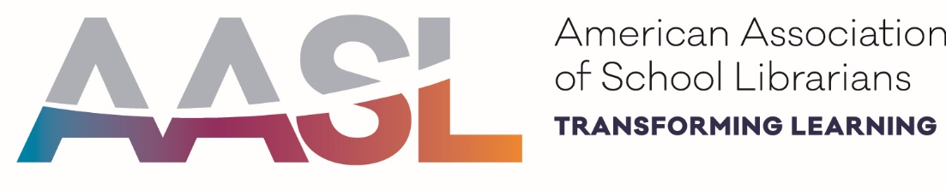
AASL Affiliate Assembly I
ALA Midwinter 2019
Saturday, January 26, 2019
Sheraton Seattle- Metropolitan A
3:00 pm – 5:30 pm

Agenda
3:00 Welcome and Greetings- Brene Duggins, Chair, AASL Affiliate Assembly
- Affiliate Assembly Coordinating Team Introductions
- Review of Concerns and Commendation process and timeline
3:10 Call for Nominees for Affiliate Assembly Chair-Elect, Blake Hopper, Chair-Elect, AASL Affiliate Assembly
Submit completed forms by 10:30 am on Sunday, January 27, during the Affiliate Assembly II meeting.
3:15 AASL Standards PD Share Site- Cassandra Barnett, Chair, State Standards Workshop Task Force
- Overview of site
- Walk through submission process
- Walk through submission viewing
3:30 AASL Standards Resources Update, Jennisen Lucas, Chair, Standards Implementation Committee
- Crosswalks
- Videos
- Professional Development
3:45 Regional Discussion Groups
- AASL Standards needs at state level
- Ideas for submission to PD Share Site
4:30 Break/Candidates Forum

