MEMBERSHIP
Submitted by Samantha Lopez, Manager, Marketing & Membership

Since opening PLA 2022 Conference registration on October 5, 2022, PLA has seen an increase in membership. However, member statistics are still below previous conference and non-conference years. Overall, ALA has been seeing an average 11% decline when compared to similar years.
How February 2022 statistics compare to previous years:
 | 2-10-22 | Sep-21 (before PLA 2022 registration opened) | Feb-20  (conf. year) | Feb-19 | Feb-18  (conf. year)
Total | 8,577 | 7,319 | 9,851 | 8,842 | 9,699
Difference # |  | +1,258 | -1,274 | -265 | -1122
Difference % |  | +17% | -13% | -3% | -12%

New/Reinstated/Renewed PLA Members (10-1-21 through 2-10-22): 3,891
- New: 1,055 (61% were also new to ALA)
- Reinstated: 562
- Renewed: 2,273
ALA Membership Type Updates
- ALA Council passed simplified ALA membership model for the Personal Members Classification of ALA Membership to be implemented in FY24
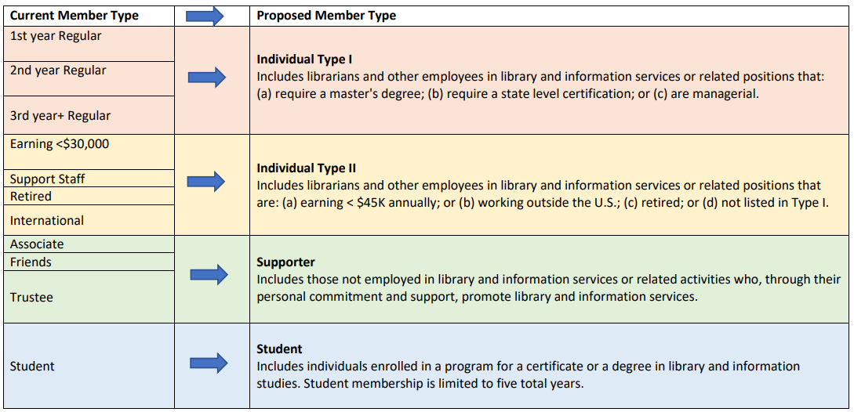
This simplified model only effects one member classification within PLA – International members. PLA International members are currently lumped into the “Individual Type I” category and have the same price as a Regular member ($78). With this new model, PLA International members will now fall under the “Individual Type II” category and be priced the same as non-salaried or retired members ($57). This only effects a minimal number of members. PLA is planning for this to go into effect FY24.
  - ALA’s reasoning behind this change is that ALA would be a second or third membership choice for international members, so they hope to increase membership in this category by making it more accessible.
- ALA is planning for an iMIS (member database) upgrade and is holding off on any membership structure changes until then.
  - This prevents the organization from piloting multi-year memberships, auto-renewals, etc.
  - ALA is hoping to have this upgrade completed within FY22, but recent IT staff departures have slowed down the timeline.
- ALA is planning for tiered membership/bundle offers to incentivize members at the point of joining or renewing. Timeline is TBD. Examples include ALA basic membership + eLearning Courses bundle; ALA + Roundtable + Division bundle; ALA + Division + eLearning Courses bundle
  - Members can currently add division or roundtable memberships to their ALA membership at any time, but the idea behind this is to present it as “added value” and one-time offer with a bundle discount.
Member Engagement & Retention Activities
- PLA 2022 Conference:
- We are bringing back the Member Lounge (booth #644) and supporting “One ALA” by sharing the space with ALA Member Relations & Services (MRS). The space will feature:
  - Reference desk with ALA resources curated for PLA Conference audience
  - ALA staff and PLA Membership Advisory Group volunteers to greet and answer questions
  - Lounge space for charging devices, relaxing
  - Craft space for button making, featuring member- and conference-themed buttons
- The Opening Session will include a warm welcome to new and returning members from PLA president (in-person audience and live-streamed for the virtual conference audience)
- General Session slideshows will feature PLA Membership promotion
- Printed program booklet features PLA Membership plug
- The Virtual Conference will feature a Happy Hour at the end of the first day, with opportunities for networking and engagement; PLA Membership Advisory Group will be invited to attend and act as “welcome wagon”
- PLA has contracted with a communications consultant to help with conference communications, including sending daily digest messages to Virtual Conference registrants featuring highlights from the conference and quotes from attendees
- The PLA Membership Advisory Group will be sending out two emails to new member attendees (both in-person and virtual):
  - 1) Pre-conference: Welcoming and inviting them to connect with members in the Member Lounge
  - 2) Follow-up: Thanking them for attending PLA 2022, reminding them of their Virtual Conference on-demand access, inviting them to an upcoming PLA event (free webinar, etc.), plugging the Member Breakfast at ALA Annual Conference in DC, and encouraging them to connect via the PLA Member Community on ALA Connect

- Ongoing and Post-conference activities:
- PLA Membership Advisory Group continues to email new members every month welcoming them to the organization and promoting 3-5 suggested activities for them to participate in
- PLA is hiring a Communications Associate who will help with member engagement and communications, including launching New Member Drip Campaign and working with ALA MRS to coordinate messaging and timing for similar campaigns (win-back campaigns, incentives, etc.)
  - Drip campaign will use email marketing software’s logic to automate messages based on activity (e.g., Join PLA and begin receiving a series of targeted, paced messages that onboard you to the organization over a period of time)
- ALA MRS continues to pilot win-back campaigns for lapsed members (2017 through present) and will continue to do so in 6-month increments. They are also testing incentives and bundles, such as discounts in the ALA Store or eLearning platform.
- MRS is also focused on first- and second-year student members, suggesting pairings (roundtables and divisions).
- ALA has been piloting the drip campaign logic, focused on new members (over one year period). They’ll be evaluating this near the end of FY22 to tweak and make changes.
PLA will work with MRS to understand timing, messaging, best practices, and lessons learned and apply to its own recruitment and retention strategies.

ALA Division Dashboard:

The dashboard below displays a PLA Membership snapshot as of February 14, 2022. The Member Types shown are ALA’s Member Types, with Regular Member making up the majority of PLA members, followed by Student then Non-salaried.

