Template/Guide for interviews to gather information on ongoing projects within automated processing of subject analysis and access

Name of project | AutoDewey
Institution | Library of Congress
Participants | Caroline Saccucci, Julianne Beall, Mark Behrens
Background expertise of participants (IT, LIS, etc) | LIS, Dewey Decimal Classification (DDC), Library of Congress Classification (LCC)
Description of project | To provide semiautomatic Dewey Decimal Classification assignment to works by and about individual authors of fiction, poetry, drama using a mapping between LCC and DDC. Also provides mapping for individual biography of athletes for specific sports.
What was need for project? | To assist the LC Dewey classifiers by having the catalogers who provide LCSH and LCC, who already know the scope of the work, to complete the Dewey number as well. This frees up Dewey classifiers to focus on more complex Dewey classification.
How long is project? (timeline) | The initial project to map some literatures to Dewey took a few months to complete. Several years later, Caroline worked with Juli Beall, a DDC editor at the time, to broaden the scope to even more literatures. Both LCC and DDC base classification of literary authors on the country where the author flourished and time period. A few years ago, classifier Mark Berhrens and Juli worked on expanding AutoDewey for sports biographies because there is a nearly one-to-one mapping between LCC and DDC.
Technologies used | AutoDewey was programmed in VisualBasic and is considered an ILS Add-on application. It is a client-side application and works with the Voyager cataloging client.
KO-techniques used | Mappings between LCC and DDC
Test documents: full-text or metadata? | Metadata
Funding | N/A
Is the project documentation openly available? | The mappings and training documentation could be made available. Right now they are used by LC staff internally. The code is stored in the VisualBasic software.
Impact to users / evaluation | Between 300 and 500 bibliographic records are enhanced monthly with AutoDewey. The work is distributed among 4 cataloging divisions at LC. It is applied for the literatures of over 42 countries and 22 individual sports. The cataloger has already decided that a work is by or about an individual author of fiction, poetry, or drama, and therefore AutoDewey applies. This follows for the cataloger of the individual biography of an athlete. The cataloger can complete all aspects of the bibliographic record and send the book on to the stacks. Dewey classifiers can spend their time on more complex Dewey classification work. The mapping work for individual sports biographies led to several EPC exhibits to clarify treatment for various sports such as martial arts and jai alai.
Pitfalls, what hasn’t gone well? | This project has very limited application because there are so few one-to-one mappings between DDC and LCC.
Links to publications and presentations | http://www.loc.gov/aba/dewey/practices/autodewey.html  http://www.loc.gov/aba/dewey/practices/autodewey-presentation.pdf
Involvement in network with similar projects / partnerships | I’m not aware of any. This is a rather unique situation because the Library of Congress assigns both LCC and DDC to many works, which allows for this cross-mapping. LC’s ClassificationWeb, the subscription-based online tool for searching LCSH and LCC, also provides correlation searching between LCC and DDC or LCSH and DDC (also MESH and DDC). This is not permit automatic assignment of DDC because the cataloger still need to verify that a classification number is still valid or is actually appropriate for the work in hand.

Modern French literature—Individual authors
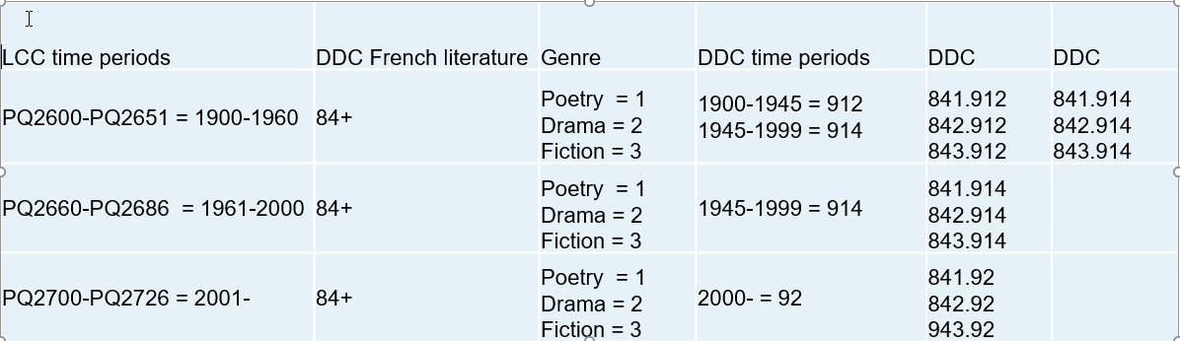
Sports biography