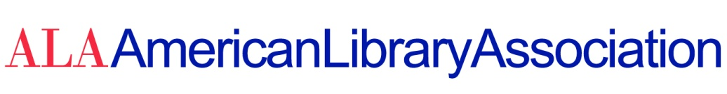

DATE: June 1, 2021

TO: ALA Council Members (2020-2021)

FROM: Marsha P. Burgess, Council Secretariat

RE: Division Annual Reports to the ALA Council

In accordance with ALA Policy A.4.2.5.5: “Annual reports from ALA division presidents shall be submitted to Council in writing for inclusion in the record of Council meetings.”

The following divisional reports are available at:

http://www.ala.org/aboutala/2021-division-annual-reports-ala-council

ALA CD#28.1 American Association of School Librarians (AASL)
ALA CD#28.2 Association of College and Research Libraries (ACRL)
ALA CD#28.3 Association for Library Services to Children (ALSC)
ALA CD#28.4 Core: Leadership Infrastructure, Futures (Core)
ALA CD#28.5 Public Library Association (PLA)
ALA CD#28.6 Reference and User Services Association (RUSA)
ALA CD#28.7 Young Adult Library Services Association (YALSA)
ALA CD#28.8 United for Libraries (UFL)

