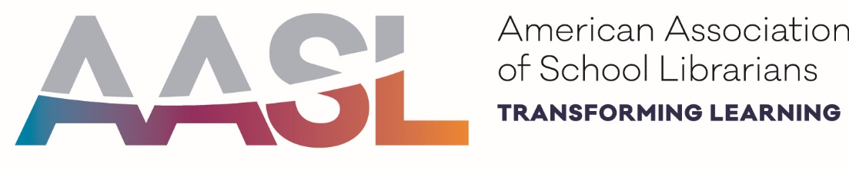

AASL Affiliate Assembly II
ALA Midwinter 2019
Sunday, January 27, 2019
Hyatt Regency Seattle- Quinault (Jr. Ballroom East)
8:00 am – 10:30 am

Agenda
7:30 Continental breakfast and coffee available
8:00 Welcome and Greetings- Brene Duggins, Chair, AASL Affiliate Assembly
8:05 AASL President Report- Kathryn Roots Lewis, President, AASL
- Current association initiatives
- Presidential Initiative Update
- Review of Concern Outcomes
- ALA Annual and AASL National schedule and event updates
8:50 Review of Concern and Commendations process- Brene Duggins, Chair, AASL Affiliate Assembly
Break
9:00 Caucus- Delegates will work in small groups to work on Concerns and Commendations
10:15 Final Announcements- Brene Duggins, Chair, AASL Affiliate Assembly
- AASL Chair-Elect Nominees Announcement
- Review of deadlines and process for Concerns/Commendations
- Meetings for ALA Annual Conference 2019, Washington, DC
10:30 Adjournment

