MINUTES:
ALA LITA Instructional Technologies Interest Group Meeting

Scheduler info: LITA All Committees Meeting
Date and Time: Saturday, June 24 10:30 AM - 11:30 AM
Location: Hilton Chicago, 720 S Michigan Avenue / 2nd Floor - International North

BUSINESS:
- Agenda and discuss about group.
- Welcome from Chair: Lilly Ramin -@lillylibrarian & Secretary: Greg Hardin @ghardin
- In-person events: Annual Conference
  - Ideas? Preferences
- Virtual
  - Meeting/presentation?
  - Any volunteers who are group members to contribute content?
- Listserv http://lists.ala.org/sympa/info/lita-insttechig
- ALA group profile site http://www.ala.org/lita/about/igs/insttech/lit-igit
- ALA Connect site: http://connect.ala.org/node/167966

DISCUSSION:

Topic ideas but subject to change based on attendee interest
  - Library instruction with technology. Library instruction for distance students.
  - Professional Development sources for teaching with technology? (Websites, Blogs, conferences, Librarians or groups on Social Media)
  - Other tools used for instruction, online or face to face using technology?
  - Challenges, trouble-shooting, tips, and best practice
  - Other experiences from your library?

Discussed points from the Joint Committee and Interest Group Chairs Meeting with LITA Executive Director, Jenny Levine.
Joined by Ray Mysels – Network Systems Specialist, Kent District Library.
Discussed:
Mobile labs and Taking computers out into the community (assisted living, schools, etc…)
Instruction Librarians’ Curriculum
GIMP & movie editing, Audacity, and other tools. Install based on user requests.
Microsoft office – word, excel, publisher workshops.
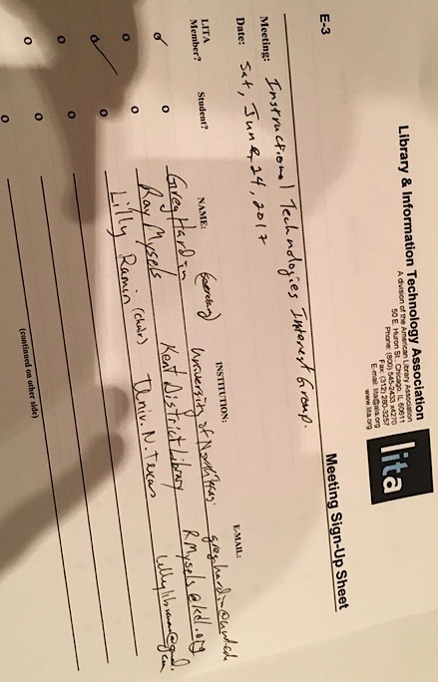
People and systems coming to ALA.
People don’t know LITA exists.
Discussions of what we each do in terms of instructional technologies
Conversations and sometimes tensions between IT and Reference/Instruction Librarians.
Needing to speak a common language.
IT – We don’t say no, we provide options.
Requires conversations & relationship building
We all have the same end-user / customer / student. End goal of success.

