Introduction
The purpose of this document is to summarize the most important details needed by your ALA organization and its leadership team to deposit your organizational documents into the ALA Institutional Repository (ALAIR). The usefulness of ALAIR to its ALA constituencies and other repository users depends entirely upon the quality of the data you submit. These guidelines not only walk you through the process of submitting to ALAIR, but also help you to describe the materials so that ALAIR users understand the context of your submissions and their relationship to other ALAIR materials. The ALAIR website does timeout after less than an hour of idle time. You may need to login again if you take a break before completing your submission.

Explanation of submission form (?)
After an ALA Archives staff person provides you with a username and password for ALAIR, , you will login at alair.ala.org. After logging in locate the submission link on the left side of the page.
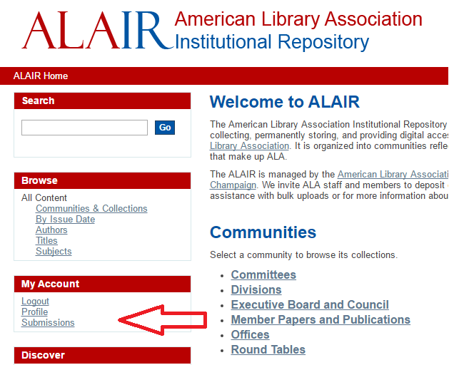
After clicking “Submissions” click “start a new submission” on the following page.
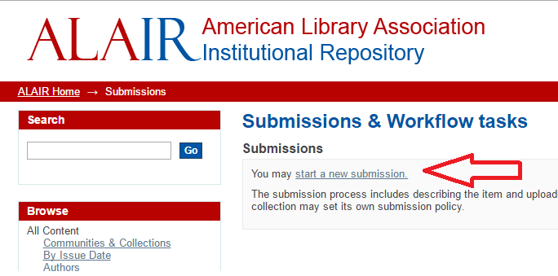
You should now see a drop down box which shows the organizations in which you have been granted permission to submit organizational documents. Be careful to select the right collection for your organization. For this example we will select “Round Tables > MAGIRT > base line,” a collection that includes issues of the MAGIRT publication base line.
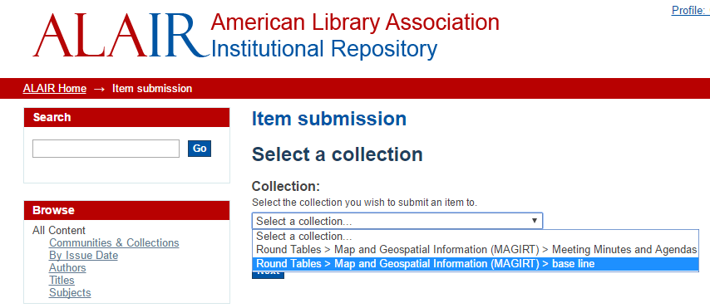
After selecting your collection, you should now see the start of the submission form. On this form you will be asked to provide descriptive information about the item you are submitting, such as Author(s), Title, Date of Issue, Publisher, Citation, Type, Language. T If you would like to include more than one author or other repeatable fields, type in the first author’s name and then select the blue add box on the right side of the page.
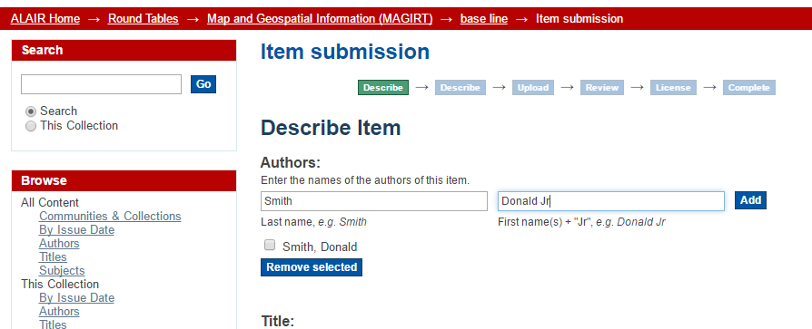

What data to put where in the submission form
In this example, we will describe the following base line document. However not every possible field will be detailed in this cliff notes document. For a full description, review the proposed
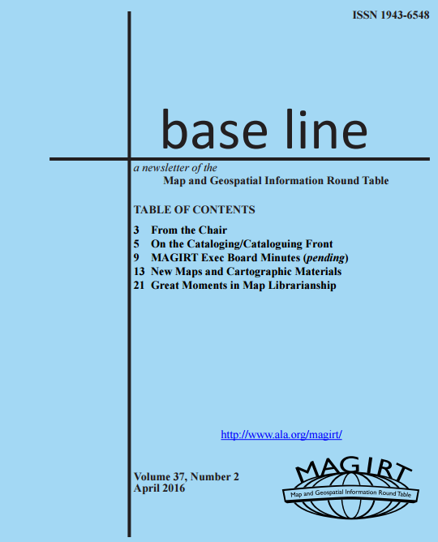

After reviewing the above example, an individual author is not apparent. But in section 6.1 of the proposed 2016 MAGIRT Application Profile, an author may be “a person, organization, or service.” For this document, we will use MAGIRT as the organizational author.

In this case, the title of our document above is base line. Input this title into the title section on the first ALAIR submission page. Next we will need to find the date of issue and the publisher. The date of issue is listed on the cover page, but the publisher is not. After the cover the base line publisher is described as ALA.

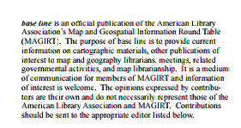

Once you feel have sufficiently described information on the first submission page, click next at the bottom of the page to continue to describe your organizational document.

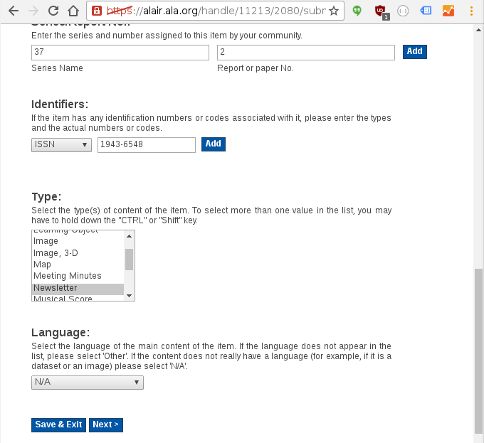

Also available at the bottom of each submission page is a “Save and Exit” option. This option does should save data on the current page you are working, so you may resume your submission after you return to ALAIR.

To return to an unfinished submission, these are located by clicking the submissions link after you’ve logged in to ALAIR, after which you will see a list of unfinished submissions.

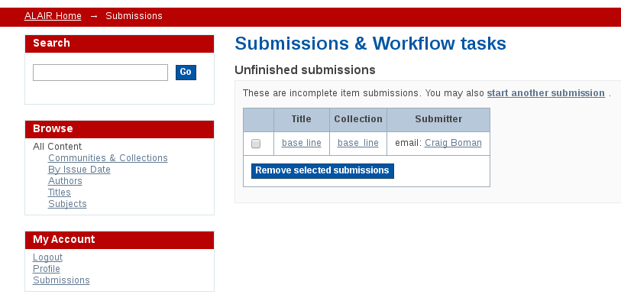

Page 2

On the second of five pages of options available for your ALAIR submission, we have the option to select subject keywords as well as some others options, not all of these options will we be able to use for our base line submission. For example we do not have an abstract available for each issue of the MAGIRT newletter. We will leave this field blank. For the “Subject Keyword” section of the submission page, attempt to Describe content of the resource. Input one keyword or subject term and then click blue Add button. (In spreadsheet for batch depositing, separate each subject term/keywords with a semicolon then space.) If no terms in the Library of Congress Subject Headings (LCSH), for topical terms, or in the Library of Congress Name AUthority File (LCNAF), for persons and entities are not possible, use a locally maintained list of preferred keywords.

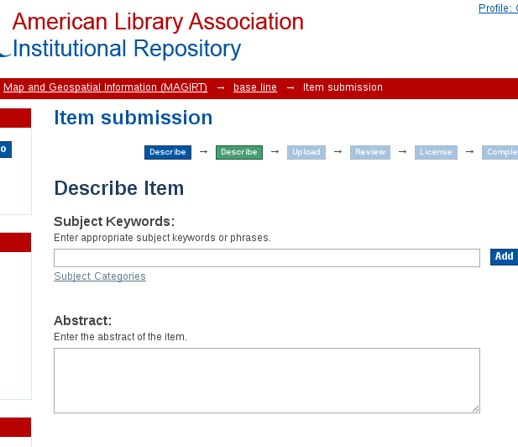

Example subject keywords for MAGIRT documents, may be:
Map and Geospatial Information Round Table (MAGIRT)
MAGIRT Executive Board
Andrew, Paige A.

After you have selected subject keywords for your submission and other necessary fields, click next at the bottom of the page. This third page will allow you to upload your document into the ALAIR. There are two more steps in this submission process before the document will be officially submitted and available to the public, so you will have a chance to review your submission after uploading it.

Page 3
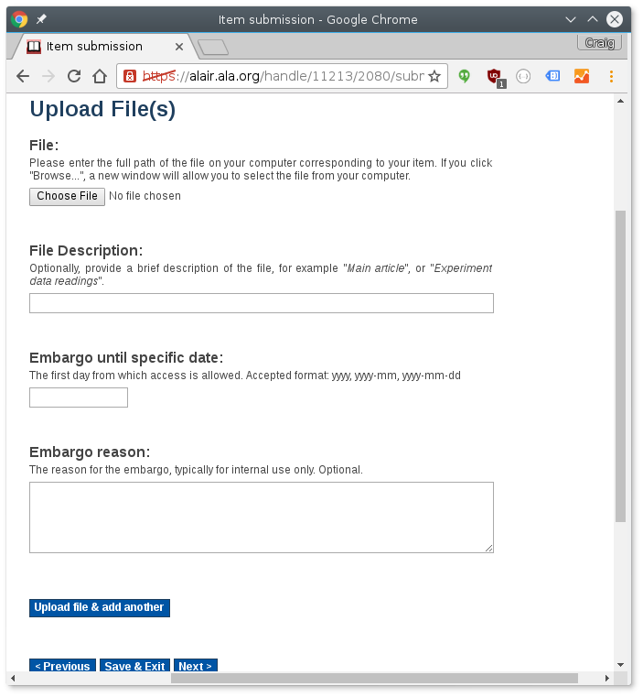

Formatting the data (e.g., capitalization, etc.)
When inputting data into ALAIR, formatting data correctly and consistently is crucial. Although the submission form does not have space to adequately describe the format needed for your data, some data format guidance is available in the proposed 2016 MAGIRT Application Profile. In the application profile you will find an example of how to format the title of a your periodical.

Information about how/where to find the ALAIR help that is already there
If you have difficulty submitting materials to ALAIR, you should first contact your ALA division representative. In the least your ALA representative should be able to direct your concern to the appropriate ALAIR support staff. If you are not sure who your ALA division rep is, contact your division or round table chair and they will direct you to your ALA representative.

https://docs.google.com/document/d/1IHPjUge3Aa-UxY8fSbdO4qml-VLheLB6KZCIyFluH2o/edit#heading=h.gjdgxs

