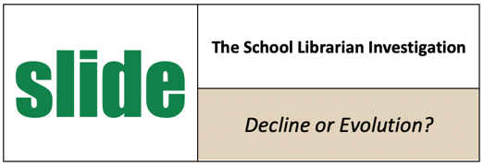
ADMINISTRATOR INTERVIEWS
What’s Behind the Slide?

Make sure your state is part of this IMLS national research project!
Through interviews, this project is attempting to learn how and why schools decide to staff libraries and/or if librarian positions are evolving or combining with other educator positions. To that end, project leaders are seeking to interview school administrators who made decisions about which librarian or similar positions were staffed and funded in their districts. Qualifying districts must meet one of these criteria:
- GAINED librarians since 2015-16
- LOST SOME librarians since 2015-16
- LOST ALL librarians since 2015-16
The research team is especially interested in learning what priorities, experiences, and factors drive staffing decisions and innovative staffing models—whether existing jobs are redefined/combined or new ones created.

Individual interviews are conveniently scheduled through October 2022, are no longer than one hour via Zoom, and will be confidential. No identifying information about the interviewee or school will be used without permission.

If you know an administrator or a school board member (retired or currently employed) who has been instrumental in deciding staffing positions and who fits one of the categories above, please ask them to complete our recruitment form providing contact info at https://www.surveymonkey.com/r/P27WN38

To view your state or district’s school librarian staffing pattern since 2015-16 through 202-21 at https://libslide.org/data-tools/custom-search

Antioch University Seattle is conducting this nationwide study called SLIDE: The School Librarian Investigation—Decline or Evolution? https://libslide.org Antioch’s Debra E. Kachel is the Project Director, and Keith Curry Lance of the RSL Research Group is the Principal Investigator. This project’s goal is to better understand current realities of school librarian staffing, not to advocate for any particular position or staffing model. Questions? Email dkachel@antioch.edu

