DRAFT PLA Strategic Plan Refresh
June 16, 2021

BACKGROUND
PLA has undertaken a process to realign its strategic activities with the current and evolving needs of its members. While our existing strategic plan (2018 - 2022) continues to be solid, we felt that the tumult of the last year and a half has necessitated a fresh look at the challenges and opportunities everyone is facing now.
In December of 2020, the PLA board and staff, supported by our consultants, began a process of information gathering, discussion, and reflection. During this time, we conducted 21 interviews and four focus groups with leaders of libraries and library organizations, and surveyed PLA members and former members to better understand their needs and goals.
WHAT WE DISCOVERED
Five major themes emerged from our work:
- Public Awareness: There is a profound lack of public awareness about the work libraries do and the value they provide for their communities.
- The profession: The work of libraries and their people is at a pivotal point in its evolution, and we must think carefully about the best ways to support all library workers, including their training, and career paths.
- EDISJ: Within our profession (and between libraries and their communities), there are far-reaching equity, diversity, and inclusion issues that must be addressed for everyone to thrive.
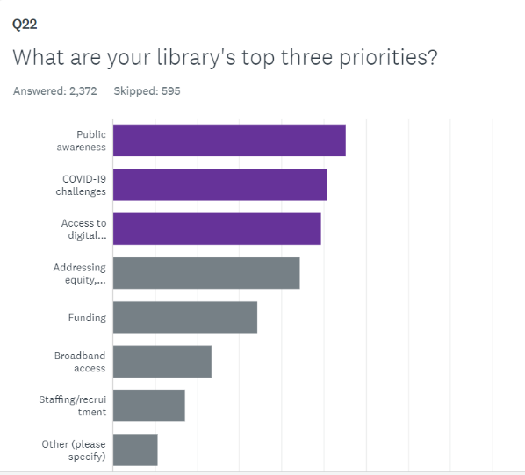
- Societal Churn: COVID-19, movements to support EDISJ, increasing disparity, growing polarization, the growth of mis- and dis-information, and other upheavals present significant challenges (and opportunities) for libraries everywhere.
- Collaboration: There are significant opportunities for collaboration between PLA and other library organizations to support the public library community in addressing the issues identified above.
Below are two specific intentions, which have been distilled from research and reflection. Each of these is backed by a set of actions we commit to taking. To give a sense of what we heard during the process, we have included thoughts from interviewees and focus group participants in their own language.
WHAT WE COMMIT TO
PLA will be bold and decisive about positions that it takes on behalf of and in service to library workers. We commit to thinking creatively and to taking action that combines the best of what we have done in the past with what we must do differently now to contribute to the preferred future of our members.
Intention One:
PLA is the “go to” support organization for individual library workers. We are welcoming to all and offer immediate and plentiful opportunities for members to engage in the exciting work we do to help people who work in libraries learn, grow, and serve their communities.
. . . It is “important to have your ear to the ground about what people’s challenges are...through relationships. What are people’s problems? Customer discovery the way entrepreneurs do it.”
Action we will take:
1. Develop PLA as the hub of a network serving public libraries. Focus on:
- Recruiting and retaining non-MLIS staff and students
“I would love to see more focus on entry and/or non-degreed staff. PLA needs to embrace non-professional staff members who are not ALA/PLA members and give them tools for learning and action.”
- Frontline staff (in addition to management)
“There’s a whole new self-discovery that we need to engage in by people who are running our libraries. Seeing oneself differently.”
- CEO support
“If you are leading a public library, you are an executive. You are running a public institution. You have a mission, revenue, expenses, employees, inventory, etc. A lot of library leaders have dismissed themselves as executives. That’s dangerous. We’ve been shy, frightened in putting ourselves out there. Accountability goes with that and there’s ambivalence about that. We have to some extent never had to be accountable for outcomes.”
- Reimagining the PLA member experience to deliver more relevance and value
“It’s about providing focus for practitioners, core elements and opportunities for change and becoming the mechanism for people to come together and bring attention to help give attention to needs and drive progress.”
“I’m a strong believer that an association or a consortium should be the beacon and R&D/learning lab for members.”
“Relevancy is key, a need to contribute to individual development and growth, and overcome generational differences.”
“People in the LGBTQ community are scared to speak up because the risk is high. People are really frightened in this country. Having discussions like this really bridges the divide between our organizations. I feel that we need a place to meet beyond the conferences...to meet all year long and know what people are working toward and help each other.”
2. Lead the charge in creating a new and powerful brand for public libraries and the people who work in them. Co-create language to:
- Describe/define the real work libraries are doing now, where is that work headed
- Describe/define what orientation and skills library workers need to be successful in this work
- Invent new/improved ways to talk about our work and the value it brings to communities
- Engage others who need/care to be involved. Not just library-affiliated organizations, but government, NGOs, etc.
“The library field is fragmented as to what a library actually is... PLA has an opportunity to create a pathway where libraries can choose their own adventure.”
“PLA wants to be responsive to its members, [and] it can push for where we want the profession to go. [With regard to] collective action, we are not meeting standards, but this is our call to do better. How do we put a stake in the ground and stop using door counts and circulation and use outcomes in a consistent way so we can share our outcomes on impact in the community?”
“[We need a] better understanding of behavior/sociology...giving people information hasn’t worked. Library staff tend to be concerned about information literacy… just pointing people to information isn’t enough.”
“We’ve lived in the “if we build it” head and let good feelings about libraries carry us. As an industry, we need to be more sophisticated.”
3. Be a partner in setting standards and supporting education of library workers.
“PLA has the ability to create a conversation about what’s core (of the profession) and be nimble without losing sight of the larger impact.”
4. Proactively collaborate with LIS educators to create innovative pathways to experience and credentials in the field.
“We’ve been on a journey to redirect our focus from being internal to external. That really requires a different set of skills than being in the business of just running the library.”
“There are so many people who can’t get into the library field b/c of the cost of the MLS.”
“People skills are essential so library staff can be “present with the community, to hear and interpret their needs.”
“Get non-white people adequately trained to lead public libraries. We have to stop using the MLS as a weapon. It’s about better representation of communities. Not MLS haves and have-nots.”
5. Find our place in the EDISJ conversation, be vocal about it, take meaningful action, and provide avenues for members to act.
“I think a piece of equity is recognizing that most library workers are not librarians (even if customers think everyone is!) and we need to share information with all staff equitably.”
“Actively recruit people of color and marginalized people. People fear each other, which is why we get into these arguments and perpetuate racism. Get people more connected. You’re not afraid of people you know.”
“It’s time to show support staff how vital they are.
“It has to go beyond conversations to action and activism. Collective action. I would love for PLA to hold public libraries accountable for diversity in staffing and offering positions to help people move into and through the profession.”
6. Speak up for good of public libraries regardless of politics including advocating for library workers. PLA will stand behind local libraries/smaller or local/regional library orgs (anti-racist work as example) when advocating and/or sharing positional statements.
“PLA could do a better job of putting their stake in the ground around an issue.”
“I’d like to see PLA become more activist and push for things like better working conditions.”
“There are libraries that want to move in these directions, but they don’t have backing.”
“We can step into the community conversation for inclusivity and diversity. [There are many] concerns about inequity and opportunity, especially in the last four years. Who’s at the table and what decisions are being made. A library has an opportunity to house these conversations.”
“There has been truly targeted undermining of institutions, we are a value-based organization, our values are the community values, and we can lead in that area. We are not neutral.”
“The most important value is courage, because without that we can’t practice the other things we do.”

Intention Two:
PLA cultivates a wide variety of mutually beneficial partnerships to advance libraries, their staff, and programs to best serve our communities.
“It’s us and us, not us and them.”
Action we will take:
1. Build and enhance relationships with partners including:
- ARSL
- ULC
- COSLA
- United For Libraries
- State library organizations
2. Work with partners to reinvent traditional spaces and systems to include culturally, racially, and economically diverse people and perspectives.
“We are not promoting or retaining people of color in the field. We are severely out of touch. If we don’t change and give up the space that is dominated by white women, we’re going to replicate racist systems.”
“PLA could be more involved in ALA caucuses like REFORMA or Black Caucus, maybe an improved relationship or partnering.”
“Help people of color work the system. Demystify it.”
3. Engage with ALA, partners, and members in providing continuing education content for PLA: for example, amplify the professional development work of state organizations, providing a conduit for sharing and collaboration.
“There’s a need for a clear system for servicing and distributing promising practices and services. What’s needed is a spontaneous system to support ideation. The pandemic has fostered more need to get together, opportunities to hear from each other.”
“[We need a] continuous education model, connected, and learning over time. A network of mentors, evaluators, and continuing education. There’s so much information out there, and zero synchronization and certification. Here’s your mentor, your outcomes. Go find materials. Build up a portfolio.”

