TO: PLA Board of Directors
RE: PLA Operations Report
DATE: September 28, 2021

ACTION REQUESTED/INFORMATION/REPORT: Information
ACTION REQUESTED BY: N/A
DRAFT OF MOTION: N/A

TECHNOLOGY
Submitted by Steven Hofmann, Manager, Web Communications
PLA 2022 Conference
The full conference website launched on August 19, 2021, once again developed and hosted by eShow. Content on the site continues to be expanded, with the opening of registration set for the week of October 4. The site now includes titles and descriptions of preconferences and concurrent sessions, and information about keynote speakers will be added as they’re confirmed.
The process to replace the provider for the PLA 2022 mobile app and virtual conference also continues, narrowed down to two most-likely candidates.
ALA Store and eLearning Site
The launch date for ALA’s new, centralized eLearning site to sell all eLearning products, originally August 9, 2021, has been delayed until November. Since June, PLA staff have been manually fulfilling orders for it on-demand webinars, which had been sold via the ALA Store. However, due to the delayed launch of the eLearning site and the PLA 2022 Conference’s increased demands on staff time, a decision was made to temporarily suspend sales of on-demand webinars until they are available via the eLearning site.

MEMBERSHIP
Submitted by Samantha Lopez, Manager, Marketing & Membership
ALA’s membership continued to decrease in July (.3%) to just under 50,000. PLA’s membership followed the same .3% loss from June to July 2021. Below are odd and even year comparisons, including changes in membership from the beginning of fiscal years through July.
Month | FY21 | FY20 | FY19 | FY18
September | 9162 | 8261 | 9341 | 7975
July | 7198 | 9363 | 7888 | 9422
Change | -1964 | +1102 | -1453 | +1447

 | FY21  To date | FY20 | FY19 | FY18 | FY17 | FY16
Average Monthly Loss Rate | 38.5% | 28.5% | 35% | 25.9% | 31.9% | 22.9%
Average Monthly Retention Rate | 61.5% | 71.5% | 65% | 74.1% | 68.1% | 77.1%

The PLA Membership Advisory Group requested more information on member drops to see if there were any trends. Below are the takeaways representing membership data from September 1, 2019, through September 15, 2021.
- Majority of drops are first-year members, followed by 10 years or less.
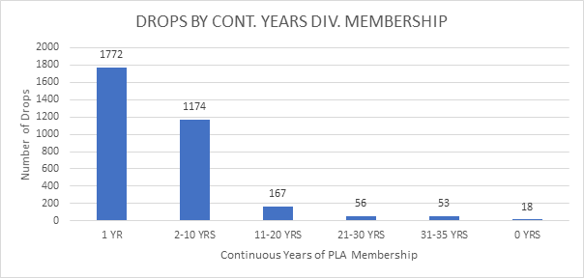
- Drops peaked May 2021. Reminder: ALA gives a grace period of 5-months before truly dropping members, so yearly renewal date would have been 5-months prior (i.e., January for May).
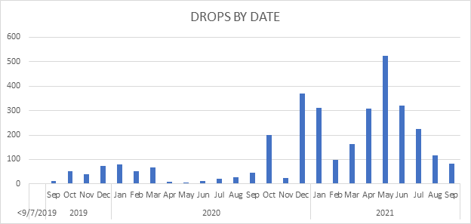
- Over three quarters of dropped members have also dropped their ALA membership.
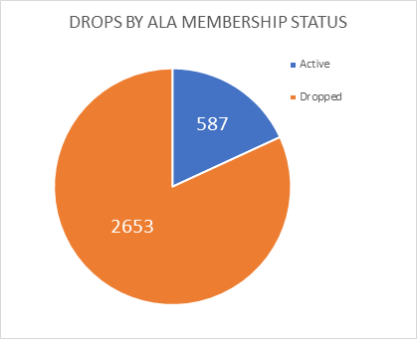

PUBLICATIONS
Submitted by Kathleen Hughes, Manager, Publications
Public Libraries Magazine is published bimonthly and sent to nearly 9,500 PLA members plus almost 500 subscribers.
In 2020-2021, to be more sustainable and in response to supply-line issues caused by the pandemic, Public Libraries introduced digital issues. Two issues in the 2020 volume year were available only in the digital format. In the 2021 volume year, three issues were (Sept/Oct, May/June, and July/August). In 2020 we saw a cost savings of nearly $28,000 and in FY 2021 we will see a cost savings of approximately $54,000 as a result of moving to digital for those issues.
During the past twelve months, Public Libraries magazine has addressed trending and challenging topics for public librarians through themed issues, listed below:

Issue | Theme
September/October 2020 | Civic Engagement
November/December 2020 | Psychological Well-Being Staff and Patrons
January/February 2021 | COVID-19 and Public Libraries
March/April 2021 | Library Funding
May/June 2021 | Partnerships
July/August 2021 | Anti-Racism
September/October | Library Safety
Two feature articles were chosen to receive the Public Libraries Advisory Committee’s Feature Article Award for the 2020 Volume Year: Define & Design: The Bookstore Model of Customer Service and Learning from our Statistics.
Like the print iteration, PLOnline focuses on issues and topics that matter to public libraries and public librarianship. Updated several times per week, the site features selections from the print magazine and unique content and averages approximately 8,000-10,000 views per week. PL Online continues to offer COVID-19 related articles among other important topics, including Gaining Patron Cooperation on Mask-Wearing , and Helping a Community Coping with Loss and Grief. In 2016, PLA started FYI: The Public Libraries Podcast as another way to explore a variety of library-world topics in‐depth. To date, we have recorded 49 podcasts. From June 4, 2020, to June 4, 2021, FYI podcasts had 9,805 individual plays. Since beginning the podcast, there have been over 55,000 individual plays. There are nearly 70,000 subscriptions via RSS and other apps.
Products + Publications
This year PLA released (or will release) three publications:
Pivoting During the Pandemic
Publication Date: March, 2021.
Offering real-life examples of what it means to be a 24/7 library, this collection from the Public Library Association (PLA) and ALA Editions shares how several libraries transitioned to virtual and socially distanced services. No matter your library’s current situation or outlook for the future, you will be inspired to adapt their ideas to suit the needs of your own organization. Among the initiatives and topics explored are
- homebound delivery;
- citizen science programs;
- virtual reference advice;
- services to small businesses;
- remote readers' advisory and book chats;
- early literacy story times;
- health services outreach;
- tech guidance for patrons;
- WIFI hotspot lending; and
- tips for social media and marketing.
See more information here: Pivoting during the Pandemic: Ideas for Serving Your Community Anytime, Anywhere
2022 Early Literacy Tips Calendar
Publication Date: October, 2021.
Based on the Every Child Ready to Read practices of reading, writing, singing, talking, playing (and now counting), each download contains twelve months of learning activities, book lists, nursery rhymes, and more. On one side is a calendar with a fun skills-building activity for each day and the other contains supplementary content like nursery rhymes, early literacy tips, song lyrics, or suggested reading material. The calendar pages are also customizable with each containing a designated spot to add to the library’s logo and contact information. This year the calendar is also available in Spanish.

The Scenarios Workbook: Using Social Work Inspired Best Practices to Support Patrons (temporary title)
Publication Date: Early Winter 2021/2022
Authored by the Social Worker Task Force, this title aims to provide information and a framework for what it means to use a trauma-informed lens with library patrons. Readers will learn what trauma is, and how it impacts library work. The book includes exercises inviting readers to reflect on common concerns in public libraries and the policies relating to these issues. Strategies for de-escalation and the impacts of involving law-enforcement and banning patrons are also covered. Finally, the book offers various scenarios that will provide readers with the opportunity to integrate what they have learned and practice responding through a trauma-informed lens.

