

**Executive Board Talking Points**

**Annual Conference 2021**

**June 23-29, 2021**

* *Pivot Strategy Update: A Necessary Focus on Membership*
* *Financial Update: Navigating Financial Recovery and Business Opportunity*
* *Operating Agreement Update*
* *Contributed Revenue Performance Update and Association Campaign Exploration*
* *Staffing Update: New Leaders for New Opportunities*
* *Public Policy and Advocacy Update*
* *Challenges to Anti-racist Books and Diversity Trainings in Libraries*
* *ALA Signs onto Joint Statement on Legislative Efforts to Restrict Education About Racism And American History*
* *Incoming ALA President Patty Wong’s Inauguration on June 29*

**Pivot Strategy Update: A Necessary Focus on Membership**

ALA’s 5-year pivot Strategy places necessary emphasis on two interdependent growth areas: increased membership and increased revenue (see below).

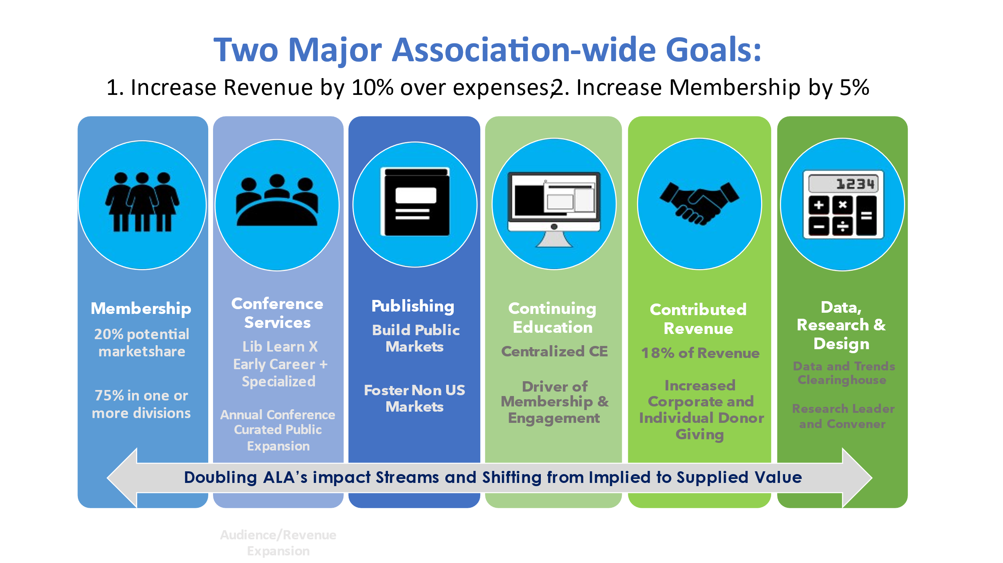

The most recent report from Member Relations and Services (MRS) indicates that the predicted dip in membership due to the impact of COVID-19 on libraries in the LIS workforce that ALA forecast was an apt prediction. Though MRS was granted additional staff resources to dedicate towards member recruitment and retention, this is an area that has not contemporarily been of specific focus for the association. The goals that ALA’s leadership and member base have prioritized for the association including the achievement of digital equity and universal broadband, diversity and inclusion in library services and information services and the LIS workforce, and the preservation of library service will require a large and strategically mobilized membership corps. More than just numerical growth, ALA’s future rests on its ability to intentionally nurture and grow future LIS leaders, systems builders, and advocates. To that end, the Forward Together Fiscal Analysis Working Group in collaboration with MRS will share a draft standardized dues report at Annual Conference. The report elevates the work previously done by SCOE to include additional detail on prospective shifts in membership dues, as well as the impact on each individual division and round table.

Reports from MRS Director, Melissa Walling and nearly every contributing office and unit speak to how central this responsibility has and will become to the association in the next few years. Walling notes, “*The experience a new member has in their first 12 months of membership greatly impacts their long-term relationship with the association. The Avenue M research indicated that the majority of former members did not make it past the three-year mark of membership; therefore, a cross-organizational team has been working to build a new member onboarding campaign.”*

MRS and Membership Committee Introduce New Membership Retention Strategy

At the beginning of the pandemic, the Committee on Membership agreed that ALA should explore establishing a fund to support members during challenging times (not limited to COVID-19). This sentiment has been echoed in various conversations throughout the organization over the last few months. This Spring, the Membership Committee proposed to establish the “ReMember Membership Fund” for which ALA’s general fund has provided seed funding to underwrite the renewal or reinstatement of ALA basic membership dues for member-library workers who are experiencing financial insecurity as a result of layoffs or reduction in wages. The fund is intended to ensure that impacted members can maintain a vital connection to the career and peer support provided through ALA’s active membership network. ALA Members may contribute to this fund that provides recipients with a non-renewable sponsorship to cover their ALA basic membership dues for one year. Recipients will be limited to current Regular, International, Library Support Staff or Non-Salaried members and those holding one of these four membership types whose membership has lapsed within the last 3 years. In addition to establishing this fund, ALA will continue to offer the following flexibility to all members:

* + Ability to pay dues through semi-annual installments with a nominal service fee.
  + Discounted Non-Salaried Membership for those earning less than $30,000 annually.
  + An extended membership grace period of 5 months (subject to ongoing review as ALA tracks how the profession rebounds from the pandemic).

The ReMember Fund launched during National Library Week 2021 with the initial $15,000 seed fund amount which will sponsor at least 100 Regular Members to start. This program was developed by reviewing the dues waiver processes and hardship funds of ALA’s Divisions as well as those of other associations including: ACRL Membership Funding for BIPOC Library Workers; ALSC Relief Renewals for BIPOC Members; REFORMA Familia Fund; Emergency Nurses Association; and more.

These efforts attest to the fact that as a member-led association, the health, generativity, and vibrancy of ALA’s membership must be a shared goal and responsibility.

**Financial Update: Navigating Financial Recovery and Business Opportunity**

Though ALA’s long-term financial health relies on its capacity to develop new business strategies and impact streams that increase members and revenue, its ability to weather the financial volatility caused by the pandemic has depended on its dexterity at managing expenses and debt. As the following budget excerpt indicates, staff and member willingness to contain spending and to prioritize work and related outputs has resulted in a comparatively favorable revenue to expense position. The fiscal year is not fully over yet, but it is clear that prudent and prioritized spending enterprise wide – like bold business development -- must continue to play a major part of ALA’s financial recovery toolkit.



Speaking operationally, as ALA prepares to close out its June Audit and end of year tax preparations, the Executive Director, Interim CFO, and ALA Treasurer are working on longer term planning for ALA’s accounting processes. Prospective planning scenarios will be shared with the Board in or before first quarter FY22.

**Operating Agreement Update**

The Operating Agreement Work Group continues its work and is also taking into consideration the Strategic Pivot Plan with its focus on strengthening collaboration and coordination among Divisions as well as increasing revenue streams.

The  Operating Agreement Work Group  is beginning to examine the Overhead Rate to understand how it currently fosters or stifles innovation, collaboration, and/or competition and if the Overhead Rate should continue, change, or be eliminated.  Key to this work is determining how to share the supporting/operational costs of ALA as well as funding initiatives that advance ALA’s values.

**Contributed Revenue Performance Update and Association Campaign Exploration**

In 2020, ALA’s Development Office was charged with raising $100,000 in contributed income for the year. In 2021, that amount was increased to $2,500,000. To date, Development has raised $4,500,000 in new grant money for the year, exceeding our budgeted goal by $2,000,000. The funds came from four donors who donated $500,000, $2,500,000, $1,000,000, and $500,000, respectively. The funds supported unrestricted general operations and re-granting. The Development Office has been notified of an additional grant of $150,000, which has not yet arrived but will increase the Development Office’s total contributed revenue to $4,650,000 as of the submission of this report. Vigorously prospecting new grants funds will continue through the end of FY21.

* *Note: Despite the Development Office’s strong performance, Accounting's most current Performance Report shows only $500,000 in “actual” revenues attributed to Development. The discrepancy between what has been raised and what is indicated in the Performance Report can be attributed to timing, as well as ongoing accounting process updates.*

Exploring an Association-wide Fundraising Campaign

ALA has an opportunity to leverage the increase in charitable giving during the pandemic. A report issued by the Fundraising Effectiveness Project (FEP) managed by the Association of Fundraising Professionals, showed that last year, overall charitable giving grew a whopping 10.6% in 2020 over 2019. The Fundraising Effectiveness Project’s *Growth in Giving* database charts giving trends from 2,496 organizations that raise $100k – $10 million annually. This increase in giving was driven by donors reaching out to help those in economic hardship during the pandemic. But many charities of all types saw giving increases. Important for ALA as it seeks to develop its individual giving cultivation strategy is the fact that data indicates that small donors, who provide much of the sustainable annual giving for many nonprofits, are growing in size and giving more generously. This news comes after numerous recent reports indicating that small donor gifts had declined over the past few years. As reported by the Chronicle of Philanthropy, gifts of less than $250 grew by a total of 15.3% last year over 2019. Gifts of $250-$999 increased by 8%, and gifts of $1,000 or more grew by 10.4%.

As it approaches its 150th anniversary, ALA is seeking to engage an experienced fundraising consultant with a proven and successful track record of campaign design and implementation to provide professional services to assess readiness for a six-year comprehensive campaign that engages its 57,000 members, library and information service partners and vendors, advocates and stakeholders, and the general public. The exploration of such a campaign would ideally begin in Fall 2021 and position ALA to carry out a comprehensive campaign that would conclude in 2026, with a tentative goal of raising $30M (approximately $5-6 M per year) in unrestricted funds to support its operations, library regranting initiatives, and directed funds for its endowment. Key components of the campaign would include foundation and corporate grants, major gift cultivation, and the expansion of the association’s individual donor base, as well as the discovery and leveraging of new and existing relationships and opportunities that may help to reach stated goals.

The Executive Director and the Development Office are working with the Philanthropy Advisory Group and Executive Board to ensure that this timely exploration launches this year with the necessary scope and schedule.

**Staffing Update: New Leaders for New Opportunities**

The pandemic has proven to be a time of deep organizational change at the talent level as well. At ALA, we have seen the retirements of longtime leaders and the resignation of a few early and mid-career staff as they move outside of the states where ALA has established nexus (full business registration) or go on to new opportunities. Though, per nationwide human resource sector data projections, ALA has planned for greater attrition than during pre-pandemic periods, the association has endeavored to fill key leadership positions and is pleased to welcome a new corps of association leaders. A current staffing status update follows.

Status of recently filled and open positions:

FILLED

* ODLOS Director. Successfully closed. New ODLOS Director, Kevin D. Strowder, will start June 21.
* PLA ED. Successfully closed. New PLA ED, Mary Davis Fournier started June 14

OPEN

* ACRL ED (search extended after final round of interviews did not yield desired candidate)
* CFO (first round of screening nearing completion)
* CIO (search underway)
* Data Officer (search underway)

Key searches scheduled for first quarter FY22:

* Director, Advancement/Development Director
* Director, Center for the Future of Libraries

**Public Policy and Advocacy Update**

**FY 2022 appropriations behind schedule**

* The Biden Administration submitted its budget on May 28, which supports $265 million in total for IMLS in FY 2022, including $197 million for the IMLS-administered Library Services and Technology Act (LSTA), and $28 million for IAL in FY 2022 administered through the Department of Education.
* The proposed number for the full IMLS budget saw an increase of $8 million from last year, which totaled $257 million in FY 2021. The proposed funding for the LSTA and IAL are level with the FY 2021 final budget, both of which received increases from the previous year.
* The annual Dear Appropriator letters, delayed by several weeks, kicked off in April. PPA [engaged library advocates](http://www.ala.org/advocacy/fund-libraries) to contact their Members of Congress to sign the fiscal year (FY) 2022 Library Services and Technology Act (LSTA) and Innovative Approaches to Literacy (IAL) letters. When the House letters closed, more than 100 Representatives signed each letter (104 for LSTA and 110 for IAL), continuing five-straight years of 100+ signatures.
* The Senate letters will remain open beyond Annual Conference, and we’re expected to surpass the number of signatures from FY 2021. These letters support funding for school libraries, and state library agencies grants to public, academic, school, and special libraries.
* ALA has been meeting with the Appropriations Committees and will submit testimony for their upcoming hearings.  With so few legislative days left in the session, we are expecting a continuing resolution to be passed before the new fiscal year in order to avoid a government shutdown.

**PPA increases visibility and support for the Build America’s Libraries Act**

* Outreach to members of Congress, allies, and library advocates on the Build America’s Libraries Act (H.R. 1581 / S. 127) has been a full court press in 2021.
* The $5 billion one-time infusion of funding for public, tribal and state libraries that serve the public would radically enhance library services—particularly in long-underresourced communities of color. PPA staff launched and regularly add content to the legislation’s [advocacy landing page](http://www.ala.org/advocacy/buildlibraries), where advocates can easily get just-in-time information about co-sponsors and quickly contact their members to thank them or to encourage them to join as a co-sponsor.
* The bill’s cosponsors have grown to 127 bipartisan Representatives – including a majority of House Democrats – and 24 Senators. The bill also been endorsed by 30 national organizations.
* On May 20, PPA released a [data brief](http://www.ala.org/news/press-releases/2021/05/america-s-aging-public-library-infrastructure-requires-billions-0) estimating the national need for public library construction and renovation at $32 billion.
* Congressional negotiations on an infrastructure package, which could include funding for library facilities as envisioned in the Build America’s Libraries Act, are expected to continue into the summer.

**Challenges to Anti-racist Books and Diversity Trainings in Libraries**

As such challenges to anti-racism themed books and DEI trainings in libraries persist and are of concern to ALA’s commitments to Access, Diversity, and Intellectual Freedom, reports from ODLOS and OIF are aggregated and excerpted here, for greater visibility.

From ODLOS: “In the third fiscal quarter ODLOS continues to respond to the significant and interrelated issues of racial justice and the diversification of the library profession, while at the same time responding to additional developing issues and opportunities. First is that we are seeing an increased demand for equity, diversity, and inclusion trainings (EDI) for libraries at the same time that we are witnessing coordinated and legislative attacks on diversity trainings and on curriculum that involves any historical or systemic analysis of racism and other forms of oppression. In working to meet the demand for EDI trainings, we are averaging six trainings per month, across a diversity of library systems, institutions, and associations (detailed below). One upcoming training we are facilitating is for the University of Oklahoma School of Library and Information Studies, as part of their virtual institute, “Developing Responsive Library Leaders.” This is amidst a new law, HB1775, [signed on May 7 by Oklahoma Governor Kevin Stitt](https://www.oklahoman.com/story/news/2021/05/07/oklahoma-gov-stitt-signs-bill-censoring-race-gender-school-curriculum/4989720001/), which prohibits Oklahoma schools from teaching critical race theory.”

From OIF: “Increasingly, libraries are experiencing pushback from members of their communities, and in some cases from their Boards, around their staff diversity trainings and public-facing anti-racism information. This is an area in which ODLOS and the Office for Intellectual Freedom (OIF) work as a team, in helping libraries navigate and respond to challenges to their diversity efforts. We are also part of a collaboration with OIF, the Chapter Relations Office and Public Policy and Advocacy working on a toolkit of effective strategies and talking points for libraries to counter the effort to ban and vilify critical race theory and anti-racist books and resources.

During the months of March, April, and May, the Office for Intellectual Freedom received more than 18 reports of challenges to anti-racist books and diversity trainings offered by libraries. Typical of these challenges is the experience of librarians at the Manitowoc, Wisconsin public library, who were criticized on social media and during virtual library board meetings by members of the public critical of the staff's plans to engage with the Project READY training materials in order to improve equity and access for their library users who are Black, Indigenous, or persons of color.

Conservative organizations and news media have been amplifying messaging that vilifies the inclusion of anti-racism and diversity materials and trainings in school curricula and in public libraries. As a consequence, at least four states have passed laws banning "critical race theory," or the teaching of "divisive topics," with other states preparing to implement similar bans.

While these circumstances challenge our mission and values, they also provide an opportunity to work with member leaders and across units to develop strategies and tools for combating racism and preventing censorship – a demonstration of the interrelatedness of intellectual freedom and social justice and the value of membership.”

**ALA Signs onto Joint Statement on Legislative Efforts to Restrict Education About Racism And American History**

In Mid-June, the Executive Board approved ALA’s signing on, along with 75 academic associations and organizations across the K-12 and college sectors, to a [joint statement](https://pen.org/joint-statement-legislative-efforts-restrict-education-racism-american-history/) opposing the wave of legislation being introduced across the country to stifle education about racism and American history in schools, colleges, and universities. Authored by PEN America in partnership with the American Historical Association, the American Association of University Professors, and the Association of American Colleges & Universities. PEN America’s Jonathan Friedman, director of free expression and education at PEN America noted, "These bills represent the most coordinated and widespread effort to legislate restrictions on speech, thought, and educational institutions in recent memory."

**Incoming ALA President Patty Wong’s Inauguration on June 29**

Members are invited to take part in a historic virtual event. Join Patricia “Patty” Wong at 1 p.m. CT on June 29, as she begins her term as the first Asian American to serve as president of the American Library Association and shares her plans for leading the association through an exciting time of change. The [virtual event](https://ala-events.zoom.us/webinar/register/WN_rNyjSdxeQdq9Z5m5s84g7g?utm_source=alanews&utm_medium=email&utm_campaign=06012021&utm_term=pressrelease) is free and is part of the ALA Annual Conference & Exhibition, June 23-29, 2021. Wong, city librarian at Santa Monica (California) Public Library, will receive the gavel (virtually) from ALA President Julius C. Jefferson, Jr., at the virtual celebration, which will honor newly elected leadership, including ALA president-elect Lessa Kanani’opua Pelayo-Lozada, ALA Executive Board members and incoming division and roundtable presidents. Register at <https://bit.ly/3i8NGx2>.