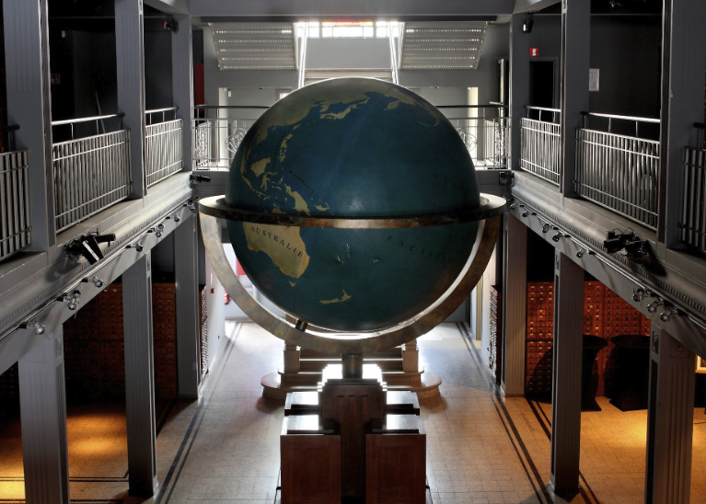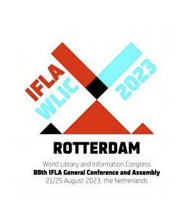  Mons, Belgium: The Mundaneum  Library History Special Interest Group Satellite Meeting  Preserving our origins: Approaches to the organization, curation, and historiography of the record of national and international organizations in libraries, information, and documentation.  Keynote Speakers:  Alistair Black, Professor Emeritus, University of Illinois  Memory and Amnesia in the Archival Practices of the World’s Library and Information Associations  W. Boyd Rayward, Professor Emeritus, University of Illinois  The emergence of a Post-World War II international information order | Schedule  Thursday, August 17  11:00 – 12:30 Film, and Tour of Mundaneum  12:30 – 14:00 Lunch  14:00 – 15:30 Alistair Black, Keynote  15:45 – 17:00 Cara Bertram, Preserving the History of the Oldest Library Association Paola Castellucci, Research & Documentation in Italy at the turn of the Century  Friday, August 18  9 -10:30 W. Boyd Rayward, Keynote  10:30 – 12:00 Peter Lor, IFLA in the International Arena Before the Second World War Yasuyo Inoue, International Influence over Japan Library Association and librarians before the World War 2  12:00 – 13:30 Lunch  13:30 – 15:00 Matilde Fontanin, A narrative of the codebreakers’ library at Bletchley Park Raffaella Vincenti, Navigating the Vatican Library institutional records. Mary Carroll, Documenting a profession: the knowledge bank of Australian and New Zealand school libraries  15:30 – 17:00 Thomas Kohlwein, Letters between Libraries: Correspondence records as sources for the history of Librarianship Jenny Bossaller & Tatjana Aparac-Jelusic, The Fragility of the Historical Record and Current Efforts to Ease Historical Work  18:00 Dinner  Saturday, August 19  9:00 – 12:00 Collaborations and Next Steps  Website (registration and extended abstracts)

