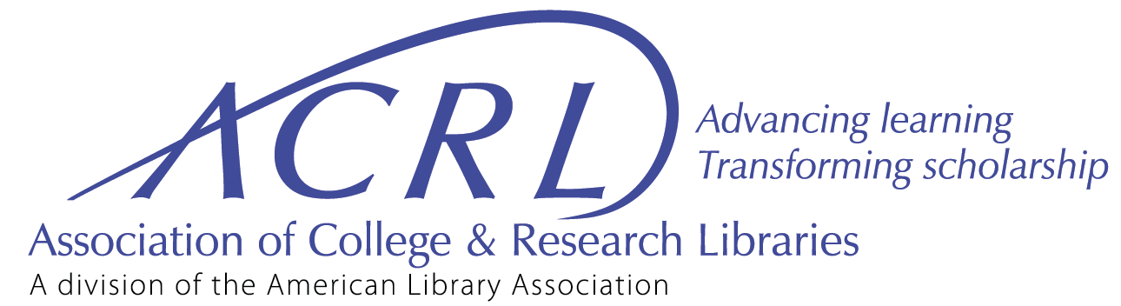
Division-level Committee Year-end Report and Work Plan Template
Each year, ACRL division-level committees should complete a year-end report and work plan. The report section should be completed by the outgoing chair. By July 31, 2020, the outgoing chair should post the combined template with only the 2019–2020 report section completed to ALA Connect.
The work plan section should be completed by the incoming chair. Committee members, Board liaison, staff liaison should all review and approve the work plan. By August 15, 2020, the incoming chair should post the combined template with the 2019–2020 report and 2020–2021 work plan sections completed to ALA Connect. Projects included in a committee’s work plan will be implemented September 2020 through June 2021.
Committee Name & Charge
Committee Name: | Government Relations Committee
Charge/Tasks: | Collaborate with ALA leadership to draft the ACRL legislative agenda. This document will speak to legislation and emerging issues of political import to higher education and academic libraries.

2019–2020 Leadership (terms: July 1, 2019–June 30, 2021)
Chair: | Amy Bush
Vice-Chair: | ***None***
Board liaison: | Jacquelyn Bryant
Staff liaison: | Kara Malenfant
Other leaders:

2020–2021 Leadership (terms: July 1, 2020–June 30, 2021)
Chair: | Kevin Walker
Vice-Chair: | Erik Nordberg
Board liaison: | Jacquelyn Bryant
Staff liaison: | Kara Malenfant
Other leaders:

Report & Work Plan Submission
Year-end report written by: | Amy Bush | Date: | June 30, 2020
Work plan submitted by: | Kevin Walker | Date: | June 30, 2020

2019–2020 Year-end Report
This report will be included in the committee’s official record of activities maintained by the ACRL staff. Brief bulleted lists are suggested for the responses.
1. What were the major projects/activities accomplished by your committee in the 2019–2020 membership year (July 1, 2019 to June 30, 2020)?
The Government Relations Committee drafted the 2020 ACRL Legislative Agenda.

2. What were the relevant results for your projects?
The Government Relations Committee completed the 2020 ACRL Legislative Agenda. On March 17, 2020, the Legislative Agenda was approved by the ACRL Board of Directors.

3. Which if any 2019–2020 projects will continue next year?
The 2021 ACRL Legislative Agenda

4. What worked well?
- Dividing up the work amongst the committee members- one committee member per issue.
- Soliciting legislative agenda recommendations from ACRL Committee Chairs and ACRL Leaders.
- Staff from ALA’s Public Policy and Advocacy office reviewed and provided valuable suggestions prior to submitting the Legislative Agenda to the board for approval.

5. What could have worked better?
It would have worked better if the committee had begun meeting earlier in the term. This was an odd year, because our original Chair was unresponsive for a couple months and it was decided that the Vice-Chair step in as acting Chair. Due to this rocky start, the committee’s first meeting was delayed until November 4, 2019.

6. How has the work/activities of your committee demonstrated commitment to equity, diversity, and inclusion, within or beyond ACRL?
Some of the issues we covered in the Legislative Agenda touched on equity, diversity, and inclusion.

7. Was there information you could have been provided before starting this project that would have made your work easier?
Yes, but only because of the odd circumstances of not first serving at vice-chair. Our staff liaison, Kara Malenfant, was wonderful and she went above and beyond to help, throughout the year.

8. What made this work most rewarding (observations/comments/accolades)?
The aftermath of knowing that advocacy is being dedicated to the Legislative Agenda’s issues that affect our academic libraries.

9. Any other comments, recommendations, or suggestions?
If either a chair or vice-chair become unresponsive and/or inactive, I suggest perhaps appointing a member of the committee to take over the role. I think it is imperative to have both a chair and vice-chair, for training purposes and for load balancing.

2020–21 Work Plan

Committee Name & Charge
Committee Name: | Government Relations Committee
Charge/Tasks: | Collaborate with ALA leadership to draft the ACRL legislative agenda. This document will speak to legislation and emerging issues of political import to higher education and academic libraries.

2019–20 Leadership (terms: July 1, 2020–June 30, 2021)
Chair: | Kevin Walker
Vice-Chair: | Erik Nordberg
Board liaison: | Jacquelyn Bryant
Staff liaison: | Kara Malenfant
Other leaders:

Work Plan Activity #1
Activity Name: | ACRL Legislative Agenda
Brief Description: | This committee will draft and revise the Legislative Agenda to provide background information for ACRL Board, staff, and members, to advocate effectively around national legislative policy issues important to academic libraries and higher education.

Activity #1 Timeline
How long will it take to do this project?
X | continuous project assigned in charge
 | short-term project that will be completed this membership year
 | multi-year project continuing past June 30, 2020. Expected completion date:

ACRL Plan for Excellence
Check the best goal and objective.
 | Value of Academic Libraries
 | Student Learning
 | Research and Scholarly Environment
 | New Roles and Changing Landscapes
 | Core Commitment to Equity, Diversity & Inclusion
X | Enabling Programs and Services (education, advocacy, publications, or member engagement)
Provide a brief sentence connecting your project to the goal area and objective you selected:
The ACRL Legislative Agenda acts as a road map to support advocacy for legislation and policies which will positively impact higher education, enabling effective programs and services.

Activity #1 Outline
Outline the steps and deadlines planned to complete the project. Attach additional sheets if needed.
Specific Action | Due Date | Party Responsible | Resources Needed  (e.g., financial, tech, staff support)
Send out introductions and welcome committee members. | July 1, 2020 | Chair | None
Initial conference call to introduce members to each other and review the work of the committee. | July 31, 2020 | Chair | None
Solicit and collect legislative issues from ACRL and ALA committees. | September 1, 2020 | Chair | None
Review 2019 Agenda and discuss what should be kept and removed. | September 30, 2020 | Committee | None
Decide on initial emerging and ongoing legislative issues to be considered for final Agenda. | October 9, 2020 | Committee | None
Draft Legislative Agenda. | November 13, 2020 | Committee | Use Google Docs to compose
Edit and prepare for submission. | December 1, 2020 | Committee | Google Docs.
Submit penultimate draft to ACRL Staff Liaison for copy editing. | Feb 5, 2021 | Chair | None
Submit final agenda, with Board action form to ACRL office for virtual vote. | April 2, 2021 | Chair | None

Activity #1 Assessment
How will success be measured?
Successful completion and approval of the Legislative Agenda by the Board.

