2020-2021 ALA CD# 37.1a
2021 ALA Virtual Annual Conference

Report on Proposed Standardized Dues Structure for ALA Divisions and Round Tables

June 08, 2021
The Forward Together Fiscal Analysis Working Group (FT-FAWG)

Report Structure

This report has three Parts.

Part 1 provides an Introduction to the efforts of the Fiscal Analysis Working Group. This contains higher level sum- mary information important as context to the Work – including Key Findings.

Part 2 provides a mid-level presentation of distilled data and textual comments based on the data in Part 3. Part 2 fo- cuses on a series of tables that provide a smaller set of distilled data from the 1,100+ data cells in Part 3. Part 2 helps Report users focus on key concepts embedded in that large data resource.

In Part 3 – this report’s foundation -- important granular details are provided in eighteen data tables and related brief textual observations based on the data.

These eighteen spreadsheets are grouped into three sets. Each set of six tables deals with one of the three proposed Scenarios for a Standardized Dues Structure for ALA Divisions and Round Tables.

Each Scenario is based mathematically on its distinct group of Dues Prices – numerically different from the Dues Prices used in the other two Scenarios.

For each of the three Proposed Dues Scenarios, there are data tables for three Member categories: Regular Member, Student Member and Retiree Member.

It is suggested that users take a moment to glance at each Part – One through Three – in that order. All of the textual and data summaries are based on the data tables in Part 3.

Part 1 begins on the following page.

PART 1. Introduction

The Forward Together Fiscal Analysis Working Group (FT-FAWG) was appointed in June of 2020 by then-President Wanda Brown. The appointment messages to members of this group included: “The charge of this group is to conduct a comprehensive fiscal analysis of the amended Forward Together recommendations. This report will be presented to ALA Council at the 2021 Midwinter Meeting. Please note that the group’s work may also continue through Fall 2021, as recommendations are implemented.”
This report explores the Membership Count and Revenue implications of the three Dues Pricing Scenarios proposed in the document Forward Together: Recommendations for a re-imagined American Library Association governance model (October 2019). The primary goal of this Working Group regarding this specific task is to provide fiscal analysis data to the groups making decisions about changes to the Membership Dues structure. As appropriate, pertinent contextual fiscal factors might also be provided. [As stated in the report of the SCOE Fiscal Analysis Working Group, “the work of SCOE was taken to enhance member engagement, not to reduce operating costs.”]
Standardized Dues Structure
The fiscal analysis of a standardized Dues Price was begun in 2018 by the SCOE Fiscal Analysis Group. The present Forward Together Fiscal Analysis Working Group (FT-FAWG) has been working with the Director of Member Relations and Services, Melissa Walling, and with Keith Brown, Senior Financial Analyst, Senior Financial Analyst of the Office of Finance and Accounting, to expand the previous analysis. FT-FAWG is taking the analysis to the next level through exploration of the individual impact on each Division and each Round Table by the given three proposed Standardized Dues scenarios. For Regular Members the proposed standardized Dues Prices provided to FT-FAWG are $60, $65, and $70. For Round Tables, the proposed standardized rates are $10, $15 and $20. Since each Division and Round Table currently has an individual Member Dues Price, the impact of this proposed standardization would vary by Unit.
Key Data and Applied Metrics Assumptions and Sources
- ALA is the source of all data displayed used in this report - unless otherwise noted. The Office of Member Relations and Services and the Office of Finance and Accounting are the primary sources of data provided by ALA.
- A Standardized Dues Prices set is intended for all Divisions, with a comparable set for all Round Tables.
- Data analysis is only for Memberships (Regular, Student and Retiree) of Divisions and Round Tables, not individual Members who often pay Dues for more than one ALA Unit.
- The Membership Count data used in the included tables of this FT-FAWG subcommittee draft report version are that of ALA Member Counts as of December 2020.
- ALA revenue amounts in the posted tables and related text are annual projections provided by ALA based on the adopted December 2020 amounts multiplied by twelve.
- New FY22 ALA revenue amounts listed in the FY22 Preliminary Dues Budget for each Division and Round Table “amounts to approximately $2.5M”. (Historical totals were included in the previous working document). The new FY22 revenue amounts are not included or reflected in posted tables and related text in this draft document.
- Pricing Sensitivity Metric: Price sensitivity related to retention and attrition, respectively, are based gener- ally on Avenue M’s ALA-commissioned survey findings and the American Society of Association Execu- tives (ASAE) general survey data. “The pricing sensitivity metric was a 20% attrition of the percentage of price increase. This is based on the typical attrition rate as found in the American Society of Association Ex- ecutives Policies & Procedures Report.”

Other Membership Decision Factors not analyzed but which might affect Member gain, retention and loss choices include professional career goals, ease of access to ALA continuing education, personal loyalties and friendships, travel interests (at least, in the past), and external marketing that highlights ALA and its Units.
Summary of Significant Findings
- ALA Dues Scenario One. Divisions & Round Tables. PDT # 1 & 2
Scenario One, overall, has the lowest level of Dues Pricing for Divisions and Round Tables among the set of three scenarios. The general outcome of Scenario One is -10% to -22% Member Revenue losses among four large Divisions. Even greater losses are projected among Round Tables (-33% to -50%) – with devastating Membership outcomes for small Units. This is without any predictable gain in Member- ship Counts. For more detail see Part 2 pages 2 & 3 of this report.

- ALA Dues Scenario Two. Divisions & Round Tables. PDT # 3 & 4
Scenario Two projects a mixed outcome of Regular Member Dues Revenue gains and losses among Di- visions. ALSC would have a +22% boost in Member Revenue with a -06% Membership Count decline. PLA would have a -16% Member Revenue change. Seven Round Tables would lose -25% of their Mem- ber Revenue because of Regular Member Dues Price reductions. All of these Member Revenue losses would be without any predictable Membership gains. For more detail see Part 2 on pages 4 & 5.
- ALA Dues Scenario Three. Divisions and Round Tables. PDT # 5 & 6
Scenario Three produces generally more uniform and benign outcomes for Divisions and Round Tables
– except a PLA Member Revenue loss at -9%. AASL’s Membership Revenue would gain +10%. ALSC would gain +29%, but with a -8% loss in Membership. A majority of Round Tables would have Member Revenue gains, ranging from +24% to +60%. Again, the smaller Round Tables would be hurt, especially SORT with a loss equivalent of its total Regular Membership.
In summary for Dues Scenario Three, Divisions’ Regular Membership-related projections for a standardized
$70 Dues Price show mostly increases in Member Revenue accompanied by decreases in Divisions’ Member Counts of -01% to -08%.
In summary for Round Tables’ Regular Membership-related projections for a standardized $20 Dues Price, projections show mostly increases in revenue accompanied by decreases in Round Table Regular Member Counts (eight at -7%, two at -20%) and SORT with a loss equivalent to all of its Regular members.

- A Possible Fourth Dues Scenario
A Mix-and-Match selection from among the proposed Three Scenarios – possibly could produce a more effective result for ALA’s standardized Dues Pricing strategy. It is also possible that a more nuanced setting of Dues Prices for individual or several ALA Units might produce an even more effective result going forward. The current data suggest possible consideration of selecting from a combination of Scenarios to accomplish more advantageous Regular, Student and Retiree Memberships – especially if the final budgeted FY22 Revenue requires increased Dues Revenue from Divisions and Round Tables.

Current Working Group Subcommittee Members
###

FT-FAWG Members | Affiliations
John A. Lehner (Chair) | University of Houston
Tom Adamich | Monroe County Community College
Victor Baeza | Oklahoma State University
Ronald A. Dubberly | Retired: Atlanta-Fulton County Public Library and Seattle Public Library
Susan Jennings | Chattanooga State Community College
Brenda Pruitt-Annisette | Kent State University
Karen G. Schneider | Sonoma State University
Carrie Willson | Calvert Library
Keith Brown | ALA Senior Financial Analyst

Report on Proposed Standardized Dues Structure for ALA Divisions and Round Tables
June 08, 2021

PART 2. Percentage Data Tables

The Percentage Data Tables (PDT) provided in this Part 2 of the Fiscal Analysis of a proposed Standardized Dues Structure for ALA Divisions and Round Ta- bles (FASDS) were derived from 18 ALA-prepared spreadsheets for Fiscal Analysis of the proposed Standardized Dues Structure. The six Percentage Data Ta- bles in this Part were prepared by Ron Dubberly, FT-FAWG member, for review and discussion by the Forward Together Fiscal Analysis Working Group mem- bers, ALA staff and others as determined by John Lehner, FT-FAWG Chair.
The Percentage Data Tables (PDT) distill pertinent data from the ALA-prepared spreadsheets provided in Part 3 of this package. Part 3 provides in 18 segments the work prepared earlier this year by the Office of Member Relations and Services.
The PDT purpose is to use a smaller set of data to help FASDS users focus on key concepts embedded in the 1,100+ data-cells prepared by Melissa Walling, Director of ALA Member Relations and Services. The basic concept of the PDT is to focus first on the key impacts of possible changes in Dues levels. This is done by measuring the percentage of change that could occur for each ALA Division and Round Table, based on the three proposed Standardized Dues Scenarios now being considered. The formulas used by ALA’s Office of Member Relations and Services reflect the following statement: “...if the price goes down, that we are assuming all members will renew as indicated by 0% in the chart. If the price goes up, then we apply the sensitivity metric.”

The four Change Measures used in the Percentage Data Tables (PDT) are the
- Dues levels proposed in each the three Dues Scenarios
- Percentage change in Dues rates for each Unit
- Percentage change in Dues revenues for each Unit
- Percentage change in Membership Counts for each Unit.

The percentages of change are provided for the three Membership Categories in the FASDS: Regular, Student and Retiree. The ALA Office of Membership estimates: ”These three membership types are the largest membership types and represent at least 75% of all divisions and round table members.”
Percentage Data Tables (PDT) for each Division and Round Table are displayed by Dues Scenarios One, Two and Three. In each table a data set is provided for each of the three Membership Types (Regular, Student and Retiree). Each table has four columns. Each column has its own data measure. Columns one and two focus on the individual Member – by displaying the Division and ALA Round Tables Unit’s respective Current Dues Rate and the Percentage Change in its Dues Rate. In columns three and four, the change measures focus on the impact to the Organization – Unit by Unit. In summary, the first two columns (white) address changes affecting Members – and columns three and four (gold) address changes to the Association through impacts on its Divisions and Round Tables.
Please see the following six pages for tables showing Change Percentages projected for each ALA Division and Round Table, as calculated for the three proposed Dues Scenarios.
The full set of spreadsheets prepared by ALA will be found in Part 3 of this report. Each is accompanied by one or more observations.

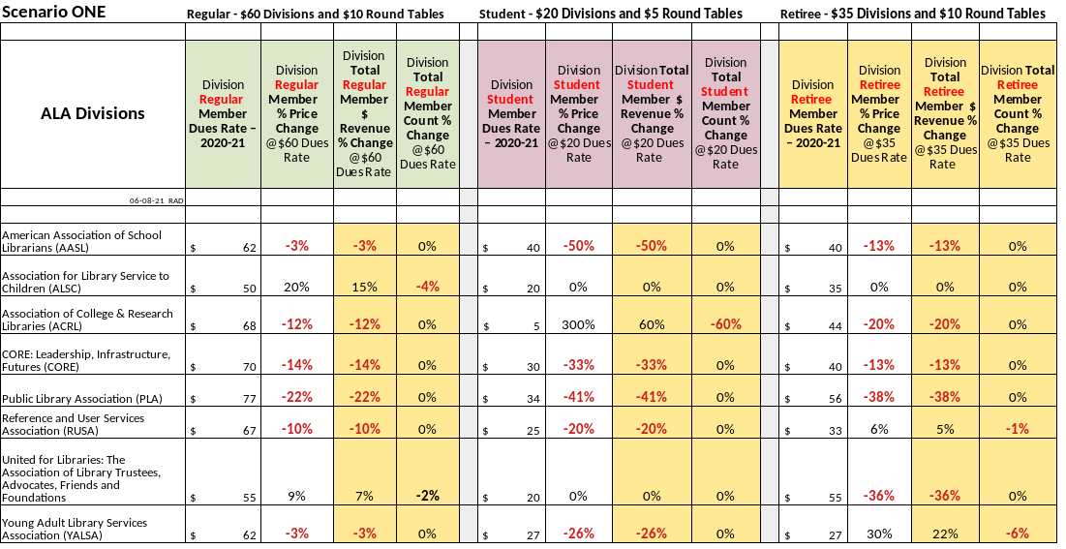
ALA Scenario One. Divisions - Regular, Student & Retiree Memberships. PDT #1

For Regular member Dues, Scenario One is projected to provide +15% Dues Revenue change for ALSC but would be accompanied by Dues Revenue reductions to ACRL (-12%), CORE (-14%), PLA (-22%) and RUSA (-10%).

Student membership losses of -60% for ACRL are projected in a 300% increase in ACRL Student Dues. No other Division is projected to lose membership with the proposed Students Dues Price of $20. Revenue losses are projected for five Divisions, ranging from -20% to -50%.

For Retiree Members in Divisions, Scenario One is projected to have membership losses in only two Units – RUSA with a -1% reduction and YALSA with a -6% member loss. Division revenue reductions are projected for five Units, with negative changes ranging from -13% to -38%.

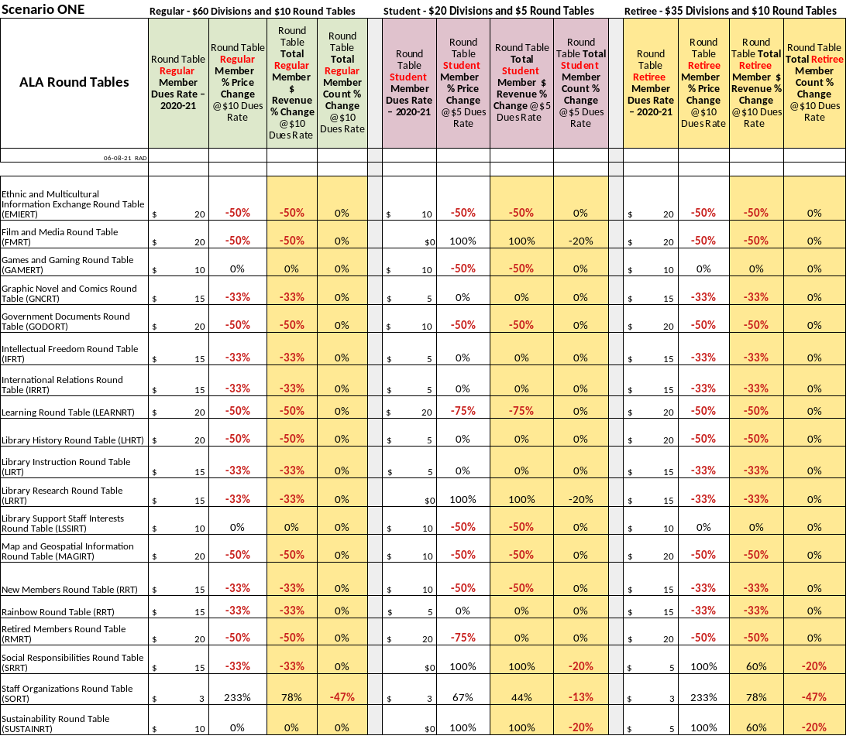
ALA Scenario One. Round Tables - Regular, Student & Retiree Memberships. PDT #2

A $10 Regular Member Price shows projected Member Revenue losses for 15 Round Tables,ranging from -33% to -50%. SORT’s 107 Member Count would be reduced by -47%. For a Student Member Dues Price of $5, fourteen Units would have no Member Count change; however, six would have Revenue losses of -50% and one with -75%. Four would have a +100% revenue increase. The $10 Retiree Member Price would be lower than the current price for all but five of the Round Tables, yielding major Member Revenue Changes (-33% and -50%) for most Units and -20% to -47% Member loss to by those with Prices currently less than $10.

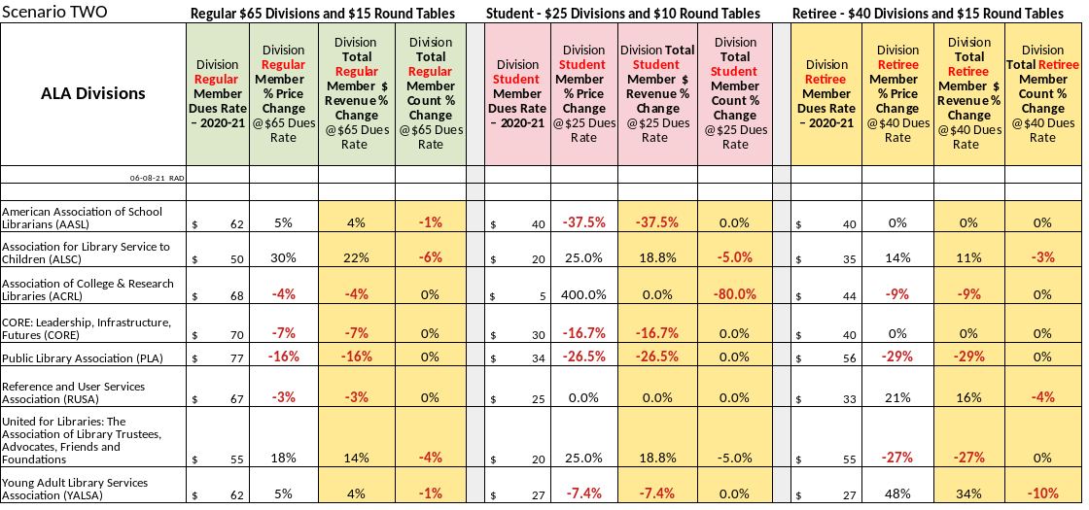
ALA Scenario Two. Divisions - Regular, Student & Retiree Memberships. PDT #3

ALSC’s Regular membership could experience a -6% drop because of a projected 30% Dues increase – with a 22% ALSC Revenue increase. United for Libraries also could lose Regular membership (-4%) with an +18% Dues Price, along with a +14% change in its Revenue level.
For this Scenario, PLA is projected to have a -16% change in its Regular membership Dues Price and in its total Member Revenue. Divisions’ Student Membership Counts – with a $65 Price - would have almost no change. PLA Revenue would be reduced by -16%; with ALSC increasing by +22% and United increasing by14%. For YALSA, its projected Retiree Member-related changes show a -10% change in Membership with a +48% increase in its Member Price and a +34% increase
in Revenue.

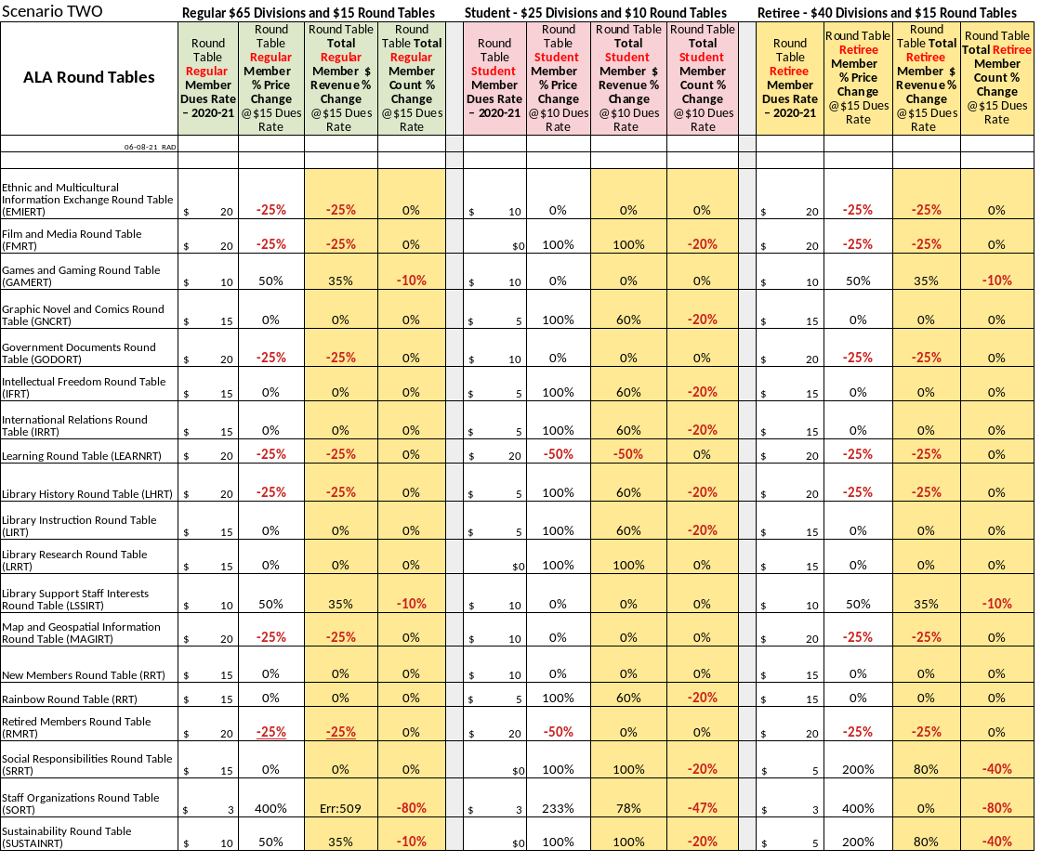
ALA Scenario Two. Round Tables - Regular, Student & Retiree Memberships. PDT #4

Regular Members’ current Price is mixed; with eight at $15, seven at $20 and four at $10. Only four Units would lose Members, three at -10%.
SORT, with a current $3 Member Price appears not viable. Student Member Revenue would increase in 11 Units – ranging +60% to +100% – but little change in revenue due to 20 or fewer members in this category. Ten Units would lose members, from -20% to -47%. At a $15 Dues Price for Retiree
Members, there would be little change in Member Count except for extremes of -40% to -80% in the smallest Units. Member Revenue losses of -25% would occur in seven Units.

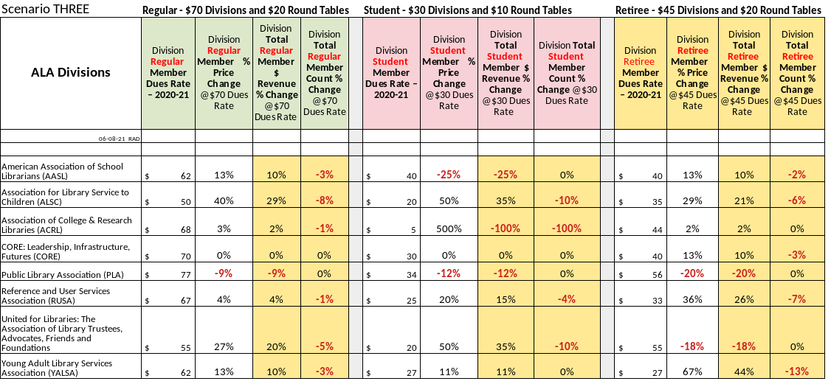
ALA Scenario Three. Divisions - Regular, Student & Retiree Memberships. PDT #5

Scenario Three projections for Regular Member Dues at an increase to a $70 Price in three Divisions would affect them as follows: AASL - Dues Price
+13%, Revenue +10% and Member Count -3%; ALSC – Dues Price +40%, Revenue +29% and Member Count -8%; United for Libraries – Dues Price +27%, Revenue +20% and Member Count -5%. PLA would have a -9% change in Dues Price and Membership Revenue but no drop in Member Count.
Student Member-related projections at a standardized $30 Dues Price show mostly increases in revenue (+11% to +35%), but accompanied by decreases in Member Counts (ALSC and United for Libraries at -10% and ACRL with a -100% loss in Student members).
Likewise, a Retiree Dues Price of $45 increased revenue for six Divisions, but the higher the percentages of Price Change and Member Revenue Change, generally Member Count losses were higher – with YALSA having a -13% Member Count loss.

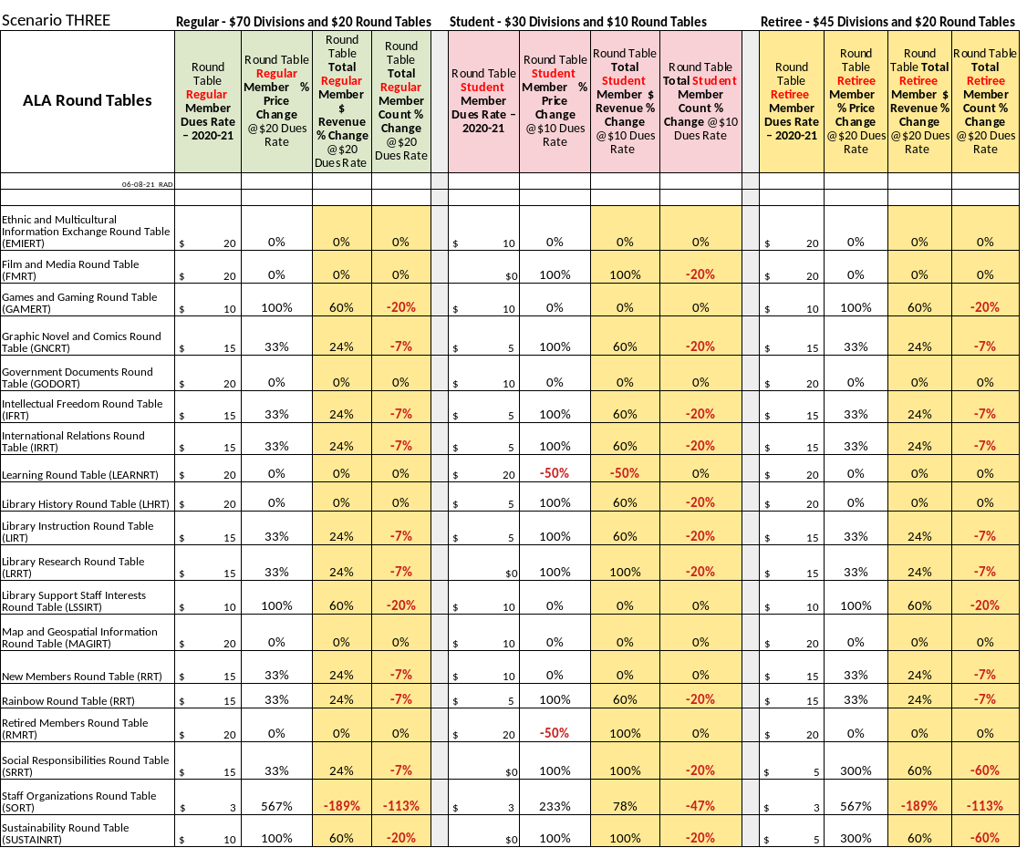
ALA Scenario Three. Round Tables - Regular, Student & Retiree Memberships. PDT #6

Regular Member-related projections at a standardized $70 Dues Price show mostly increases in revenue accompanied by decreases in Member Counts (nine at -7%, three at -20% and one (SORT) with a loss of all Regular members). Student Members, with Dues price increases in 11 Units included 10 at
+100% and one at +23% (SORT). Revenue would increase in12 Units, ranging from +60% to +100%. Member losses in 11 Units range from -20% ti -47% (SORT). With a Retiree Member Dues Rate of $20, seven Units would have a +33% Price increase and a projected Member loss of -7%. Three smaller Units (SRRT, SORT and SUSTAINRT) are projected to have Membership Count changes of -60% to total loss with a $20 Retiree Member Dues Price.

Report on Proposed Standardized Dues Structure for ALA Divisions and Round Tables
June 08, 2021

PART 3.

ALA DATA TABLES with Related Textual Narrative Regarding
Fiscal Analysis of Proposed Standardized Dues Structure of ALA Divisions and Round Tables

ALA is the source of all data displayed in the tables in this report section - unless otherwise noted.
The data provided in the eighteen tables displayed on the following pages were prepared by ALA. The Office of Member Relations and Services and the Office of Finance and Accounting are the primary sources of the data. Victor Baeza, member of the Forward Together Fiscal Analysis Working Group (FT-FAWG), and others provided assistance to the Offices as needed.
Text displayed in green was prepared by Melissa Walling, Director of Office of Member Relations and Services. Text displayed in black was prepared by Ron Dubberly, (FT-FAWG member) for this review draft report.

Notes [by Melissa Walling, Director. Office of Member Relations and Services]:

These pricing scenarios were bundled for ease of presentation, and to give a big picture overview, but you could separate the division from the round table.

For each scenario, the pricing sensitivity metric was a 20% attrition of the percentage of price increase. This is based on the typical attrition rate as found in the American Society of Association Executives Metrics Report.

There was no analysis done on the possible negative impact on ALA dues revenue if the member drops their ALA membership because these are likely to be negligible; however, we recommend including this analysis when the price points are finalized.

These three membership types are the largest membership types and represent at least 75% of all divisions and round table members.
Scenario One - Regular - $60 Divisions and $10 Round Tables / Student - $20 Divisions and $5 Round Tables / Retiree - $35 Divisions and $10 Round Tables
There was a total combined loss of $310K (12% decline in revenue)
Even the groups that were most impacted by price increases (such as ALSC and SORT), their overall revenue increased.
For all but 1 division and 3 round tables these price points represented a total loss of revenue.
Scenario Two - Regular - $65 Divisions and $15 Round Tables / Student - $25 Divisions and $10 Round Tables / Retiree - $40 Divisions and $15 Round Tables
There was a total combined loss of $95K (4% decline in revenue)
Almost half of divisions and round tables lost revenue at these price points
Scenario Three - Regular - $70 Divisions and $20 Round Tables / Student - $30 Divisions and $10 Round Tables / Retiree - $45 Divisions and $20 Round Tables
There was a total combined increase of $79K (3% increase in revenue)

Only 1 division and 6 round tables lost revenue at these price points

Scenario One

Revenue

“There was a total combined loss of $310,000 (12% decline in revenue)” for Regular, Student and Retiree membership types.

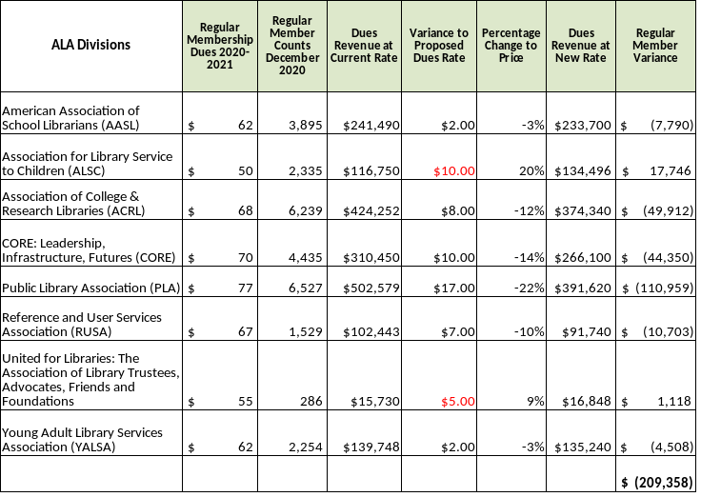
Even the groups (Units) that were most impacted by price increases (such as ALSC and SORT), their overall revenue increased

For all but 1 division and 3 round tables these price points represented a total loss of revenue.” (Melissa Walling)

Scenario One
Divisions - Regular Memberships - $60

The changes in Division Dues pricing for Regular Members range from -22% to +20%, with four being reduced between -10% and -22% – and one being increased by 20%.

Scenario One
Divisions – Student Memberships - $20

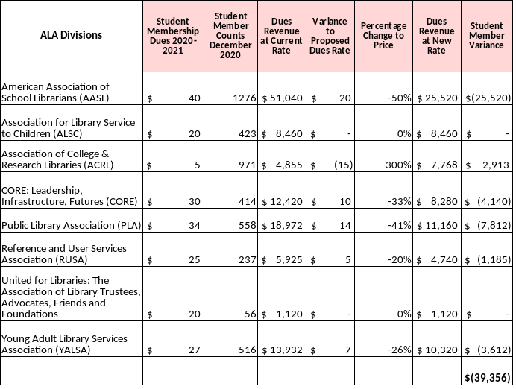
The changes in Division Dues pricing for Student Members range from -50% to +300%, with five reduced between -20% and -50%, two with no change and one increased by 300%.

Scenario One
Divisions - Retiree Memberships - $35 AND Total of Each Divisions’ Variance

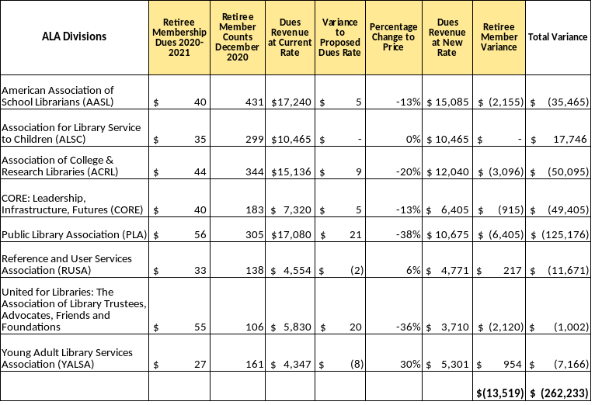
The changes in Division Dues pricing for Retiree Members range from -38% to +30%, with five reduced between -13$ to -38%, one with no change and two increased (one by +6% and the other by +30%).

Scenario One
Round Tables - Regular Memberships - $10

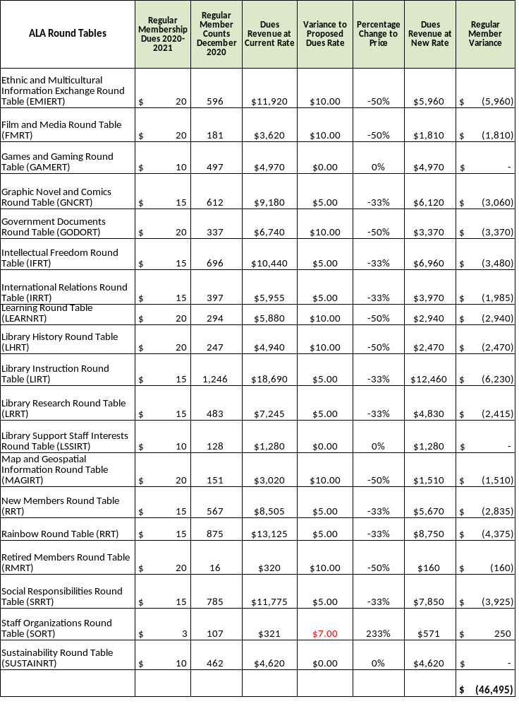
The changes in Round Table Dues pricing for Regular Members range from -50% to +233%, with 16 being reduced (eight by -33% and seven by -50%), three with no change and one being increased 233%.

Scenario One
Round Tables – Student Memberships - $5

The changes in Dues pricing for Student Members range from -75% to +100%, with eight reduced between
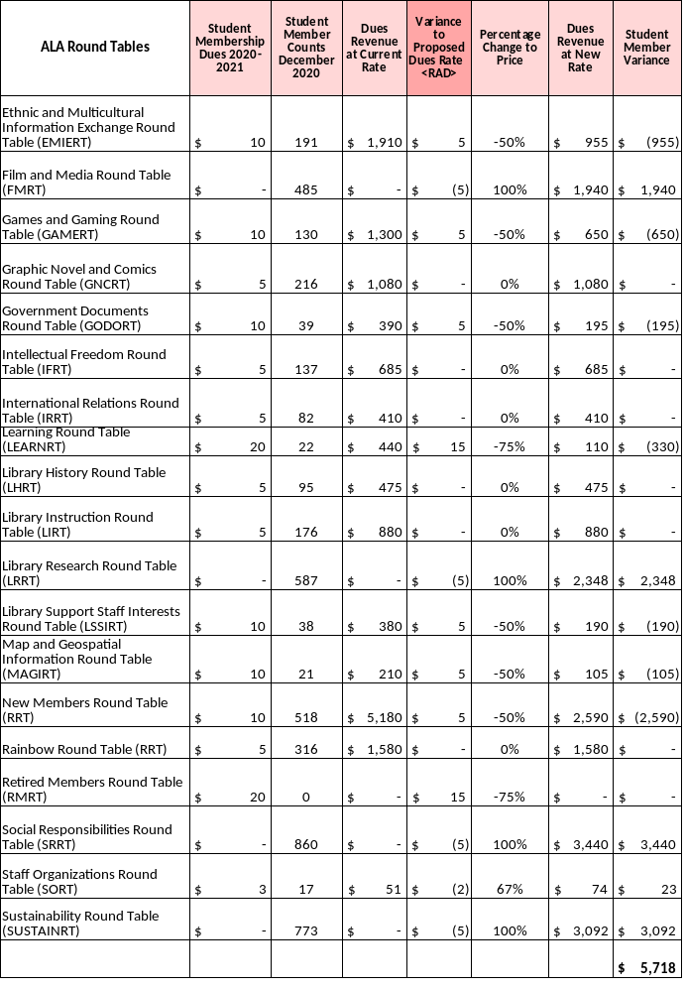
-50% and -75%, six with no change and four increased by 100%.

Scenario One
Round Tables - Retiree Memberships - $10 AND Total of Each Divisions’ Variance

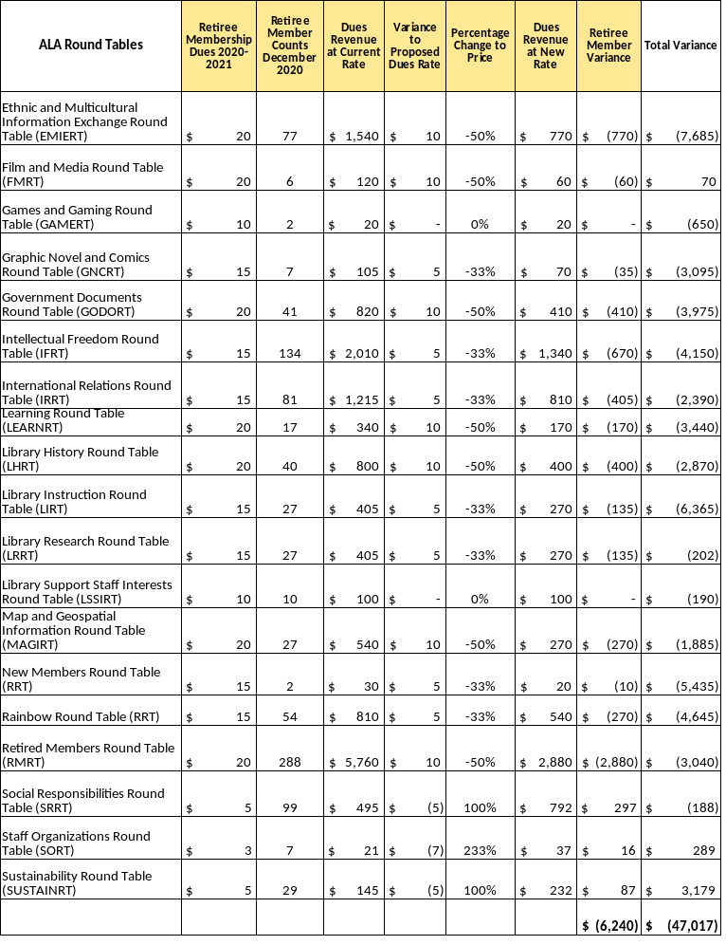
The changes in Dues pricing for Retiree Members range from -50% to +233%, with twelve reduced between -33% to -50%, one with no change and three increased (two by +100% and one by 233%).

Scenario Two

Revenue
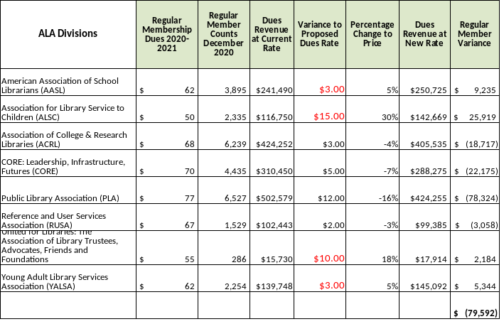
There was a total combined loss of $95K (4% decline in revenue) for Regular, Student and Retiree membership types.
Almost half of divisions and round tables lost revenue at these price points

Scenario Two
Divisions – Regular Memberships - $65

The changes in Dues pricing for Regular Members range from -16% to +30%, with four changed between - 03% and -16% – and two increased by +18% and +30%.

Scenario Two
Divisions – Student Memberships - $25

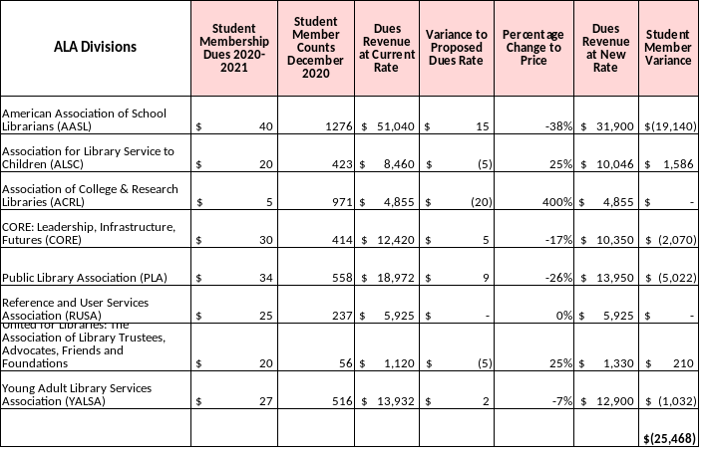
The changes in Dues pricing for Student Members range from -38% to +400%, with four reduced (one each at -07, -17%, -26% and -38%), one with no change and three with increases (two at +25% and one at 400%).

Scenario Two
Divisions - Retiree Memberships - $40

The changes in Dues pricing for Retiree Members range from -29% to +48%, with three reduced (=09%,
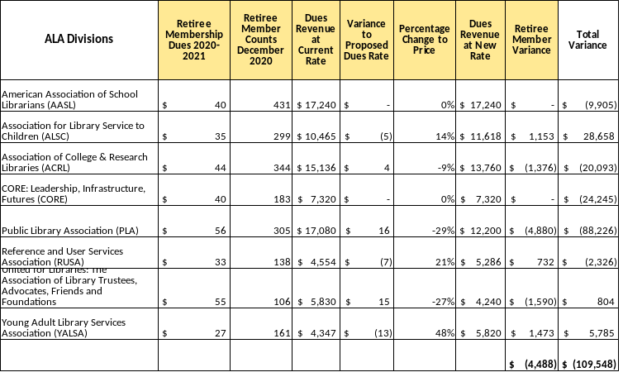
-27% and -29%), three increased (one by 48%) and two with no change.

Scenario Two
Round Tables - Regular Memberships - $15

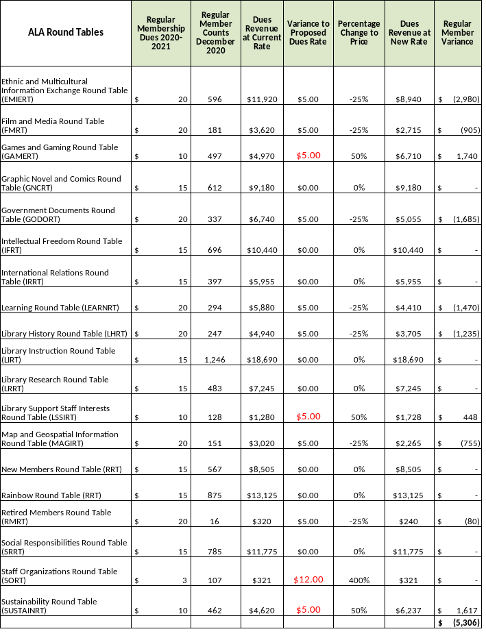
The changes in Dues pricing for Regular Members range from -25% to 400%, with seven reduced by -25%), eight with no change and four increased (three by 50% and one by 400%).

Scenario Two
Round Tables - Student Memberships - $10

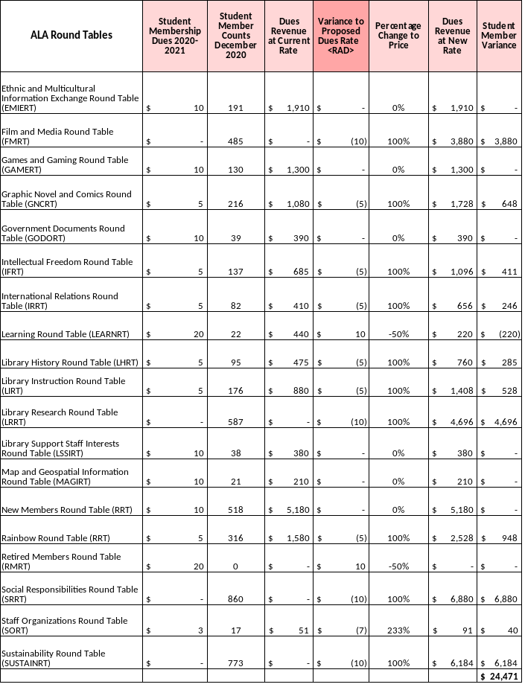
The changes in Dues pricing for Student Members range from -25% to +400%, six with no change and thirteen increased (two by 50%, ten by 100%, and one by 233%).

Scenario Two
Round Tables - Retiree Memberships - $15 AND Total of Each Divisions’ Variance

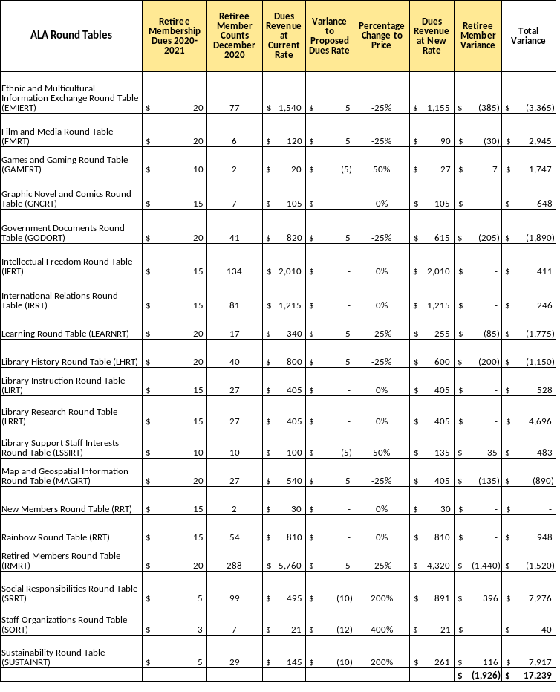
The changes in Dues pricing for Retiree Members range from -25% to +400%, with seven reduced by 25%, seven with no change and five with increases from 50% to 400% (the latter with a projected total loss of membership).

Scenario Three

Revenue
There was a total combined increase of $79K (3% increase in revenue) for Regular, Student and Retiree membership types.

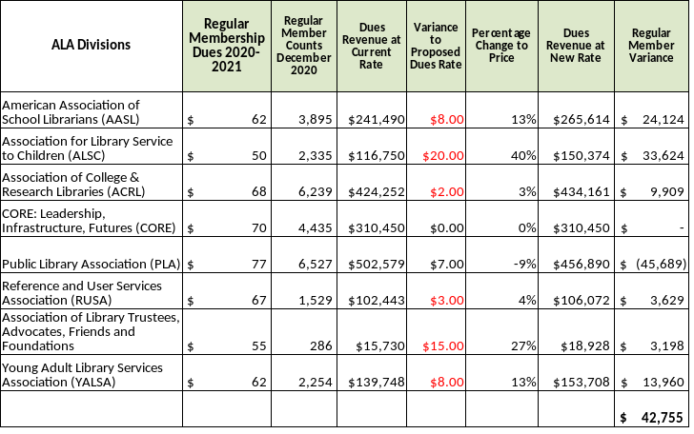
Only 1 division and 6 round tables lost revenue at these price points

For Retiree Members in Divisions, Scenario One is projected to have minimal effects – except for YALSA with an estimated - 6% member loss.

Scenario Three
Divisions – Regular Memberships - $70

The changes in Dues pricing for Regular Members range from -9% to +40%, four with changes between
-09% and +04%, two at +13%, one at +27% and one at +40%.

Scenario Three
Divisions – Student Memberships - $30

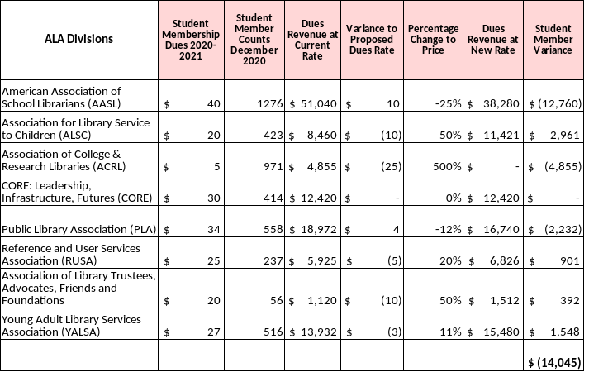
The changes in Dues pricing for Student Members range from -25% to 500%, with one reduced by -25%, one by -12%, one with no change, one at +11%, one at +20%, two at +50% and one at +500% – the latter with a projected total loss of Member Count.

Scenario Three
Divisions - Retiree Memberships - $45 AND Total of Each Divisions’ Variance

The changes in Dues pricing for Retiree Members range from -20% to +67%, with two reduced in the
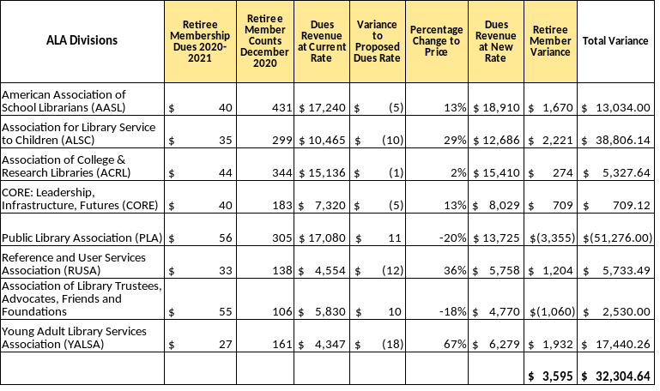
-20% range, one at +02%, two at +13%, and one each at +29%, +36% and +67%.

Scenario Three
Round Tables - Regular Memberships - $20

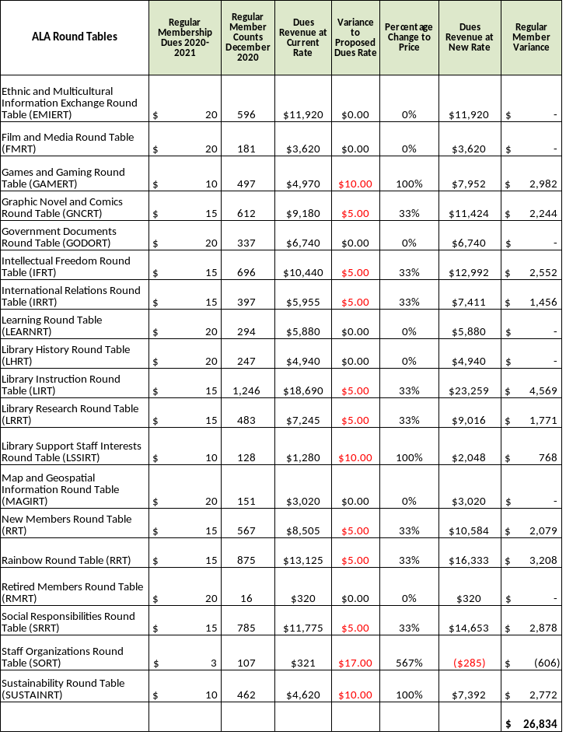
The changes in Dues pricing for Regular Members range from 0% to 567%, with none reduced, seven with no change, eight increased by 33%, three by 100% and by 567% (the latter with virtually all its members lost).

Scenario Three
Round Tables - Student Memberships - $10

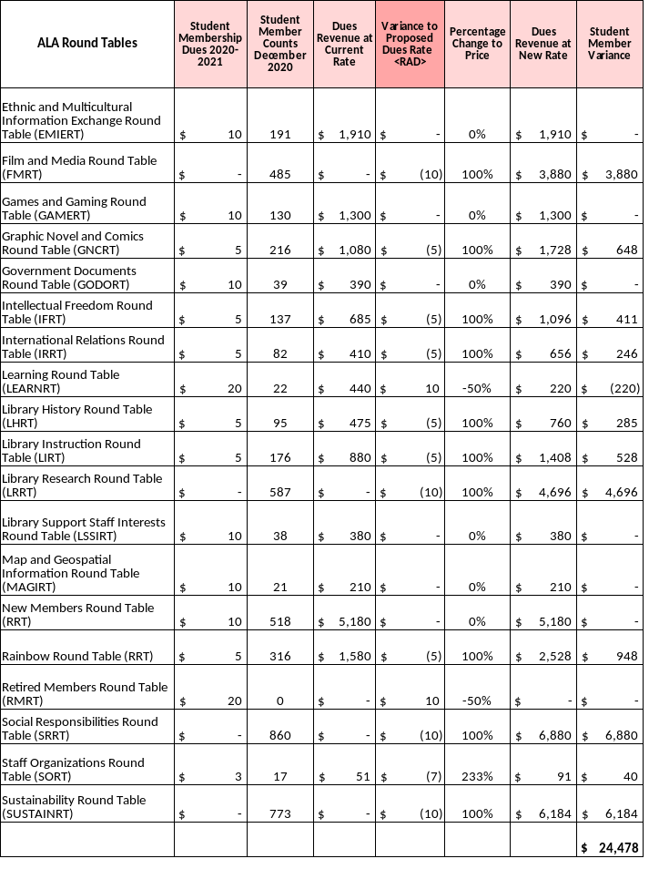
The changes in Dues pricing for Student Members range from -50% to +233%: with one reduced by -50%: six at 0%, ten increased by 100% and one by 233% (the latter with projected total loss of small membership).

Scenario Three
Round Tables - Retiree Memberships - $20 AND Total of Each Round Table’s Variance

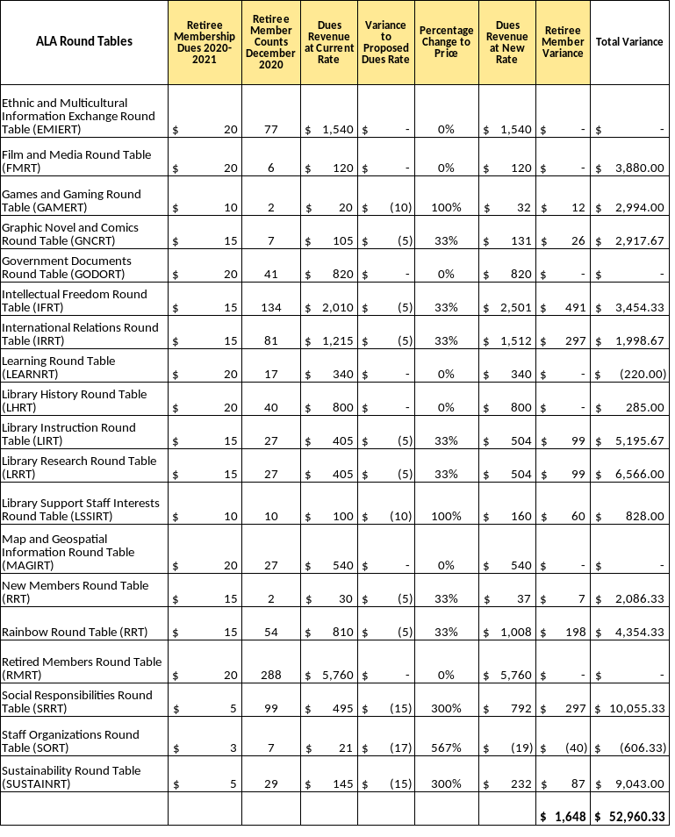
The changes in Dues pricing for Retiree Members range from 0% to 567%, with none reduced, seven with no change, twelve increased (seven at 33% and five increased between 100% and 567% (the latter with a projected total loss of membership).

###

